**Network Engineering Capstone  
Functionality Report**

# Introduction

*Provide a functionality report detailing the 10 test-case scenarios used to verify the utility of your network project. Seven of the test-case scenarios must be from the provided predefined list, with the remaining three test cases created by you. The functionality report should be written so that a networking peer could replicate the steps for a successful test of your networking solution.*

|  |  |
| --- | --- |
| **Student Name** | Macallister Crane |
| **WGU Student ID** | 012024879 |
| **WGU Student Email** | mcran55@wgu.edu |

Legend

SW: Switch ISP: Internet Service Provider

MLSW**:** Multi-Layer-Switch ACL: Access Control List

FW: Firewall SVI: Switch Virtual Interface

AP: Access Point DNS: Domain Name System

DHCP: Dynamic Host Configuration Protocol DMZ: Demilitarized Zone

NAT: Network Address Translation VPN: Virtual Private Network

OSPF: Open Shortest Path First IP: Internet Protocol

AAA: Authentication, Authorization, Accounting LAN: Local Area Network

VLAN: Virtual Local Area Network WAN: Wide Area Network

NTP: Network Time Protocol SSH: Secure Shell

*All commands displayed in the Steps portion of a Test Case assume global configuration mode unless otherwise specified.

# Test Case #1: Device Discovery and Reachability

*Your network solution must include multiple network segments with access controls that allow traffic from a device on one network to access the resources of a device on another network. Similarly, there must be devices on one network that cannot access resources on a different network.*

## Functionality

*Describe the* ***functionality*** *of the test case in relation to your network project. Identify the relevant tools (devices, subnets, etc.) used in this test case and their specific interactions.*

 An ACL is blocking all subnets in the Monterey location from accessing the Santa Cruz location Engineering department and allowing only the Santa Cruz Engineering department to be able to access all Monterey location devices except for the 192.168.99.0/24 subnet and the DHCP Server on VLAN 102.

**Functionality**: Traffic should be blocked from any address on the Monterey location to the 192.168.40.0/24 network. Traffic should be allowed from the 192.168.40.0/24 ENG network to any address in the Monterey location except for the 192.168.99.0/24 Guest department and VLAN 102 by using ACLs that are created on the MAIN-FW and FACTORY-FW. An ACL will be created on the MLSWs to block specific traffic to the Guest department (192.168.99.0/24 subnet). An implicit deny will block all other traffic that isn’t specified in the ACLs.

## Network Diagram or Segment

*Provide a* ***network diagram or segment*** *visualizing the topology and devices used in this test case.*

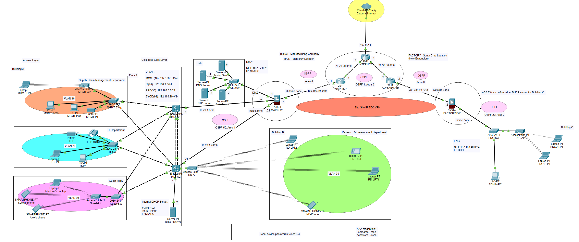

## Testing Method

*Summarize the* ***testing method*** *used to verify functionality of the network project within the virtual lab environment, including any metrics of success.*

**Testing**: Testing for this case came after the IP addresses, VLANS, and DHCP were successfully established in Test Case 4 and Test Case 7. To test functionality, I went into a device in each subnet in the Monterey location and attempted to ping the 192.168.40.0 ENG department. I received the message "Request timed out" on each attempt which verified traffic being successfully blocked by the “RES1” ACL on the FACTORY-FW. I then went into a device in the 192.168.40.0/24 ENG department and was successfully able to ping a device in each subnet in the Monterey location (except the 192.168.99.0/24, and VLAN 102 subnets) which verified ACL “RES” functionality on the MAIN-FW.

## Process List

*Provide a comprehensive* ***process list*** *of the steps taken within the network project to run the testing method. Include screenshots to illustrate the process and ensure clarity for others attempting to replicate the test.*

**Steps**: The steps taken for allowing traffic from the 192.168.40.0/24 network into all Monterey subnets except the 192.168.99.0/24 subnet involved configuring the “RES” ACL outbound on the MAIN-FWs OUTSIDE interface to permit traffic from the 192.168.40.0/24 network. I've also decided to allow traffic on ports 443, 80, 53, and 123 for best practice. Also, for the ASA-FWs to inspect ICMP traffic I had to configure policy-map because this is not set by default. On the FACTORY-FW I’ve configured an almost identical configuration for ACL “RES1” excluding the ENG department entry due to it applying to outbound traffic. An implicit deny is applied to any entry not specified. To block traffic from going in and out of the 192.168.99.0/24 Guest network I’ve configured ACL 101 on g1/0/5 for both inbound and outbound traffic that is explained further upon in Test Case 2. The commands to configure ACL “RES” on the FWs were:

MAIN-FW:

access-list RES permit tcp any any eq 80

access-list RES permit tcp any any eq 443

access-list RES permit udp any any eq 53

access-list RES permit udp any any eq 123

access-list RES permit ip 192.168.40.0 255.255.255.0 any

access-list RES permit icmp any any

access-group RES in interface OUTSIDE

policy-map global_policy

class inspection_default

inspect icmp

service-policy global_policy global

Factory-FW:

access-list RES1 extended permit tcp any any eq 80

access-list RES1 extended permit tcp any any eq 443

access-list RES permit udp any any eq 53

access-list RES1 extended permit udp any any eq 123

access-group RES1 in interface OUTSIDE

policy-map global_policy

class inspection_default

inspect icmp

service-policy global_policy global

Screenshots for Test Case 1:

*Access Control Lists on the MAIN-FW and FACTORY-FW*

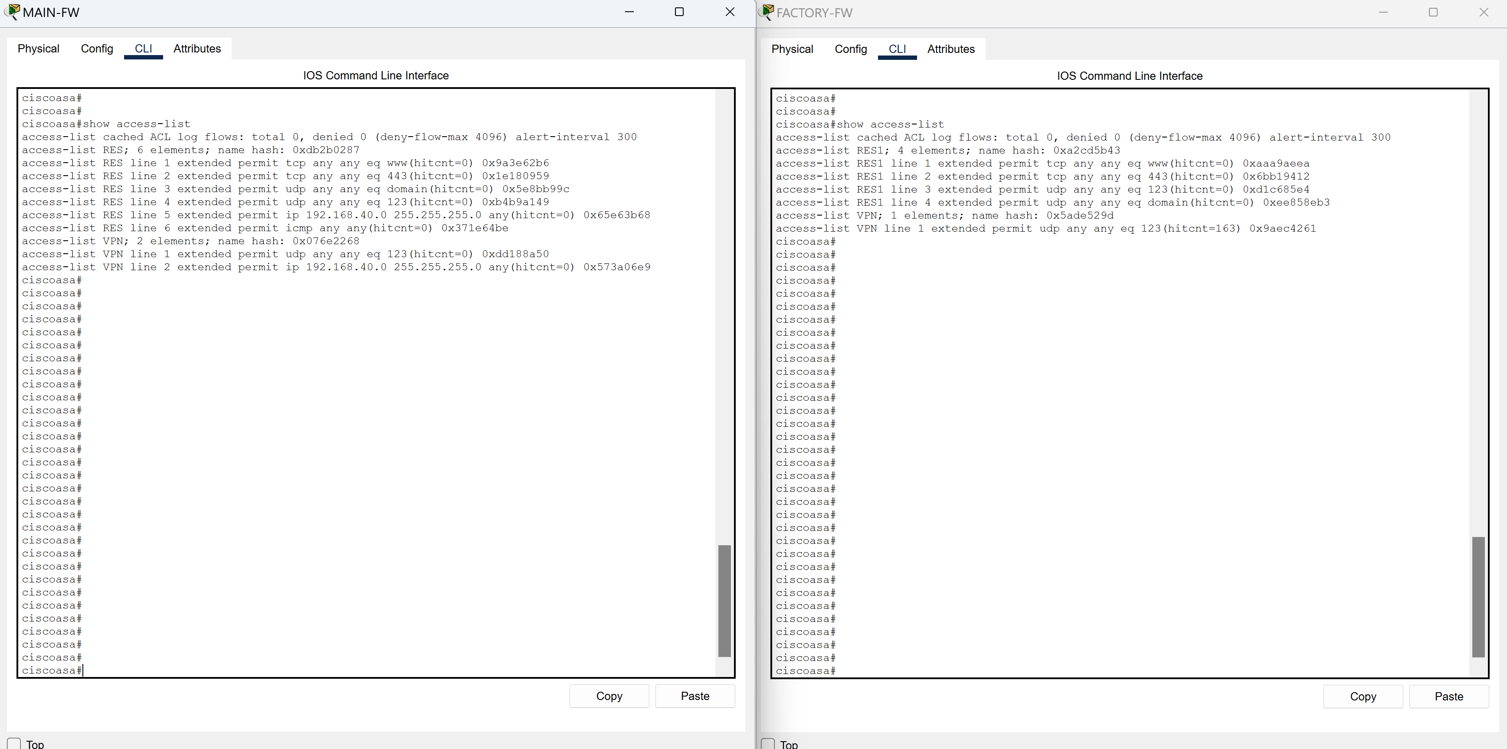

# Test Case #2: Administering an Access Control List for Guest Access

*Your network must utilize an access control list that allows guest access. Guest access should be limited to internet traffic only.*

## Functionality

*Describe the* ***functionality*** *of the test case in relation to your network project. Identify the relevant tools (devices, subnets, etc.) used in this test case and their specific interactions.*

My network begins by segmenting all departments with VLANS and applying a /24 mask to each department VLAN. Each department VLAN is connected via L3 switches that have been configured with inter-vlan routing to establish connectivity between departments. The network in Building A is subnetted from the MAIN-FW to the DMZ and configured with a /28 bit mask. There is also VLAN 102 configured with a /30 bit mask from MLSW2 to the DHCP server. In between the MAIN-FW and the MLSWs I have used /30 masks for further segmentation of the network. On the MLSWs I have configured ACLs to allow the Guest department access to the DNS server through port 53. The ACLs deny all other traffic from the Guest department to ensure that the internal network is secure from guest access. The departments within Building A have been allowed connectivity between each other except for the Guest department. As described in Test Case 1, the FWs at Site A (Monterey) and Site B (Santa Cruz) have been configured with ACLs to establish connectivity from the Engineering department at the Santa Cruz location to all departments in the Monterey location except for the Guest department.

**Functionality**: When using a device on the 192.168.99.0/24 subnet I should not have access to any other device outside the department except for the DNS server for web access. In addition, I should not have access into the Guest department devices from any external IP address outside the 192.168.99.0/24 range.

## Network Diagram or Segment

*Provide a* ***network diagram or segment*** *visualizing the topology and devices used in this test case.*



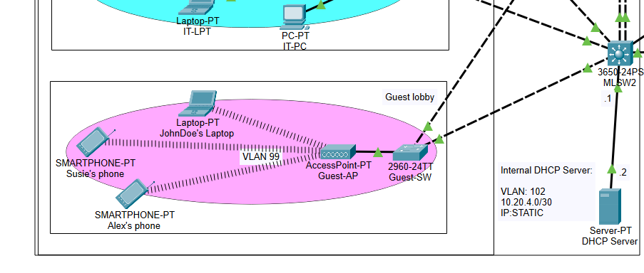

## Testing Method

*Summarize the* ***testing method*** *used to verify functionality of the network project within the virtual lab environment, including any metrics of success.*

**Testing**: To test functionality of ACL 101 I went into JohnDoe’s-PT on the Guest network and attempted to ping a device in each of the department. Pings from the Guest department were unsuccessful which indicated that ACL 101 was blocking traffic out of the Guest department. Lastly, I went to a device in each department and attempted to ping the JohnDoe’s-PT device inside the Guest network with no success which validated that ACL 101 was blocking traffic into the Guest department as well as out of it.

## Process List

*Provide a comprehensive* ***process list*** *of the steps taken within the network project to run the testing method. Include screenshots to illustrate the process and ensure clarity for others attempting to replicate the test.*

**Steps**: To configure this correctly I went into configuration mode on the Core MLSW's to configure an ACL with the following commands:

MAIN-MLSW2:

access-list 101 permit udp host 10.20.2.4 192.168.99.0 0.0.0.255 eq 53

access-list 101 permit ip host 10.20.2.4 192.168.99.0 0.0.0.255

int vlan 99

ip access-group 101 out

MAIN-MLSW1:

access-list 101 permit udp host 10.20.2.4 192.168.99.0 0.0.0.255 eq 53

access-list 101 permit ip host 10.20.2.4 192.168.99.0 0.0.0.255

int vlan 99

ip access-group 101 out

Screenshots for Test Case 2:

*Access Control List 101 configured on MLSW1 and MLSW2:*

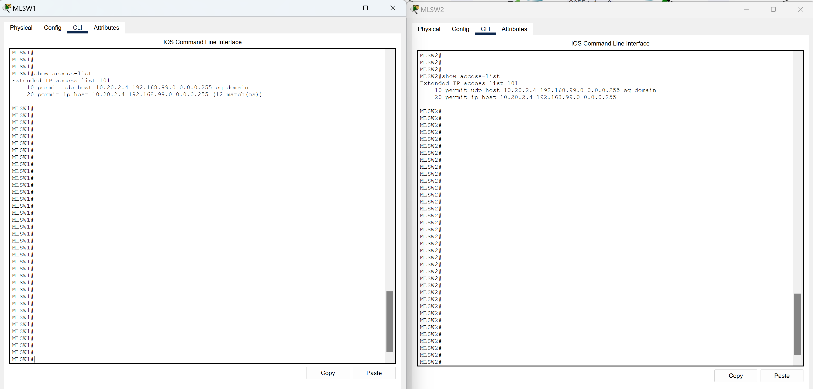

*Access Group 101 applied to VLAN 99 (Guest Department):*

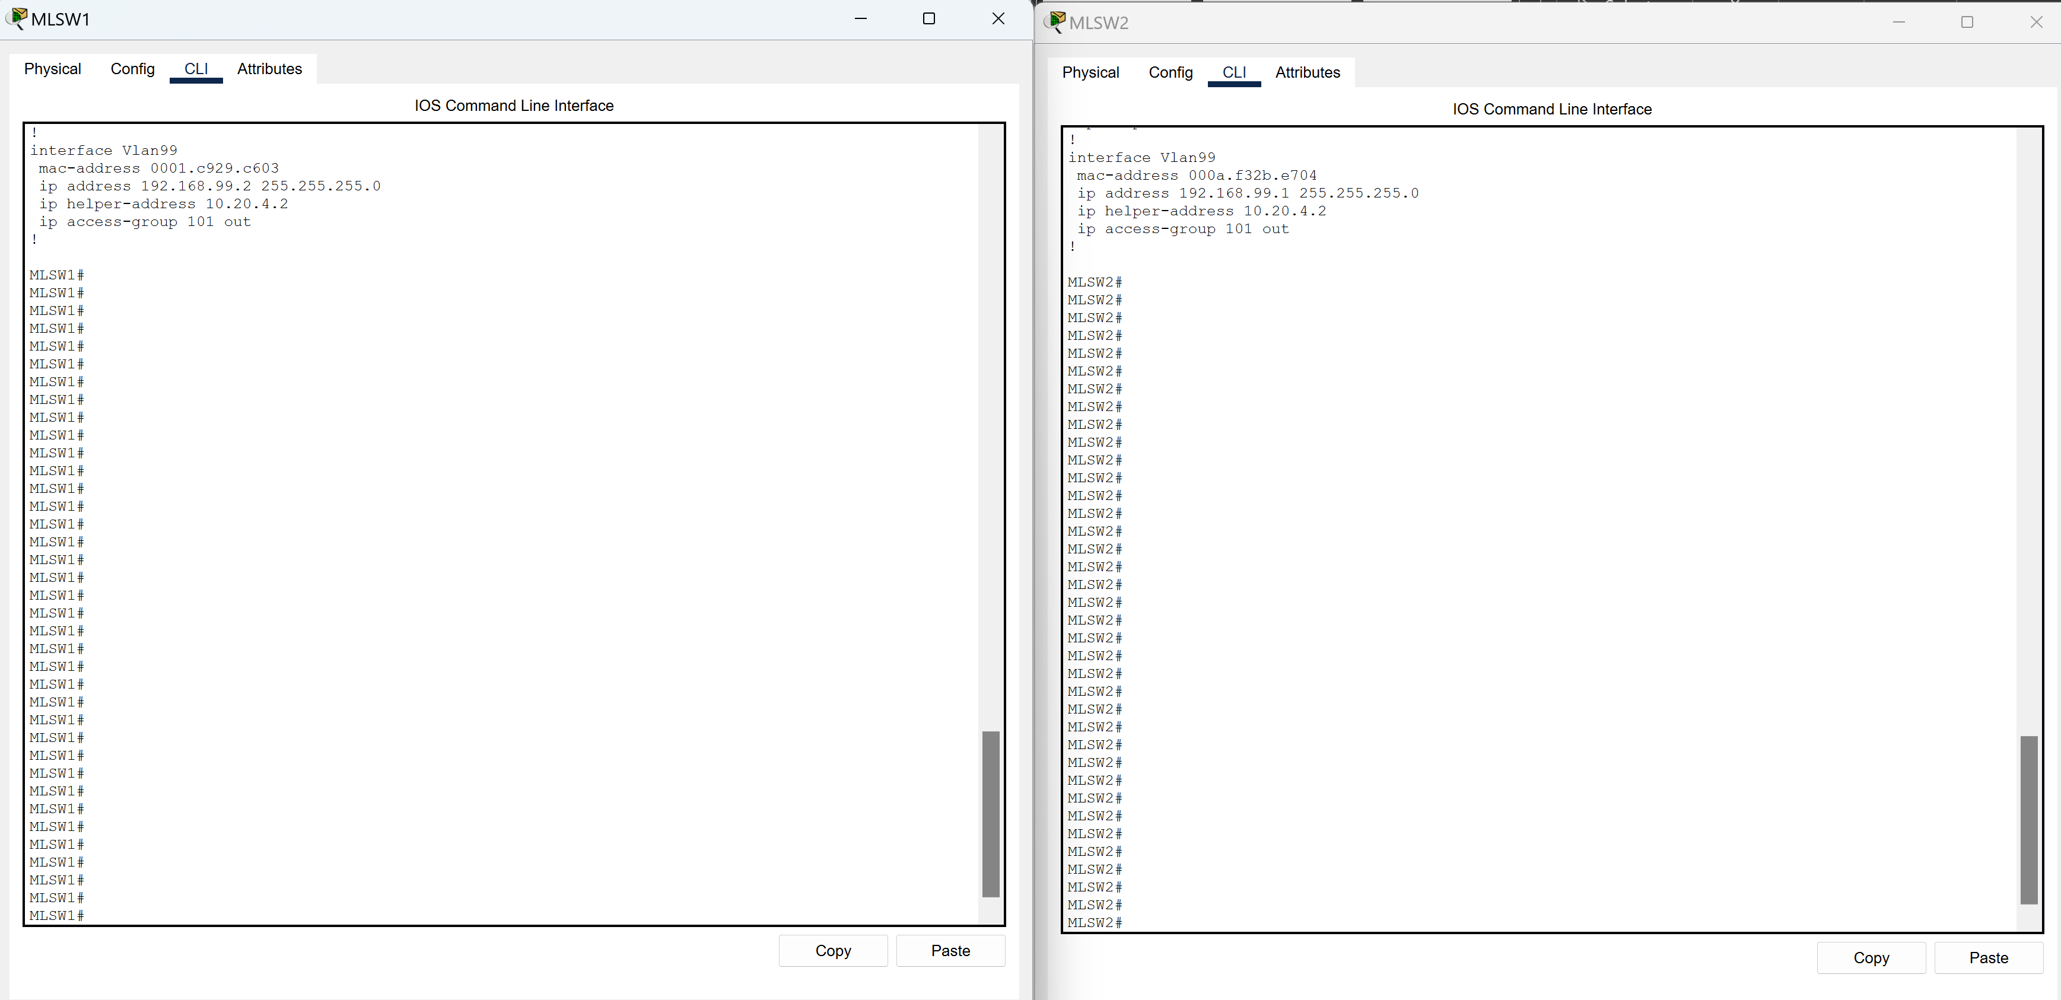

*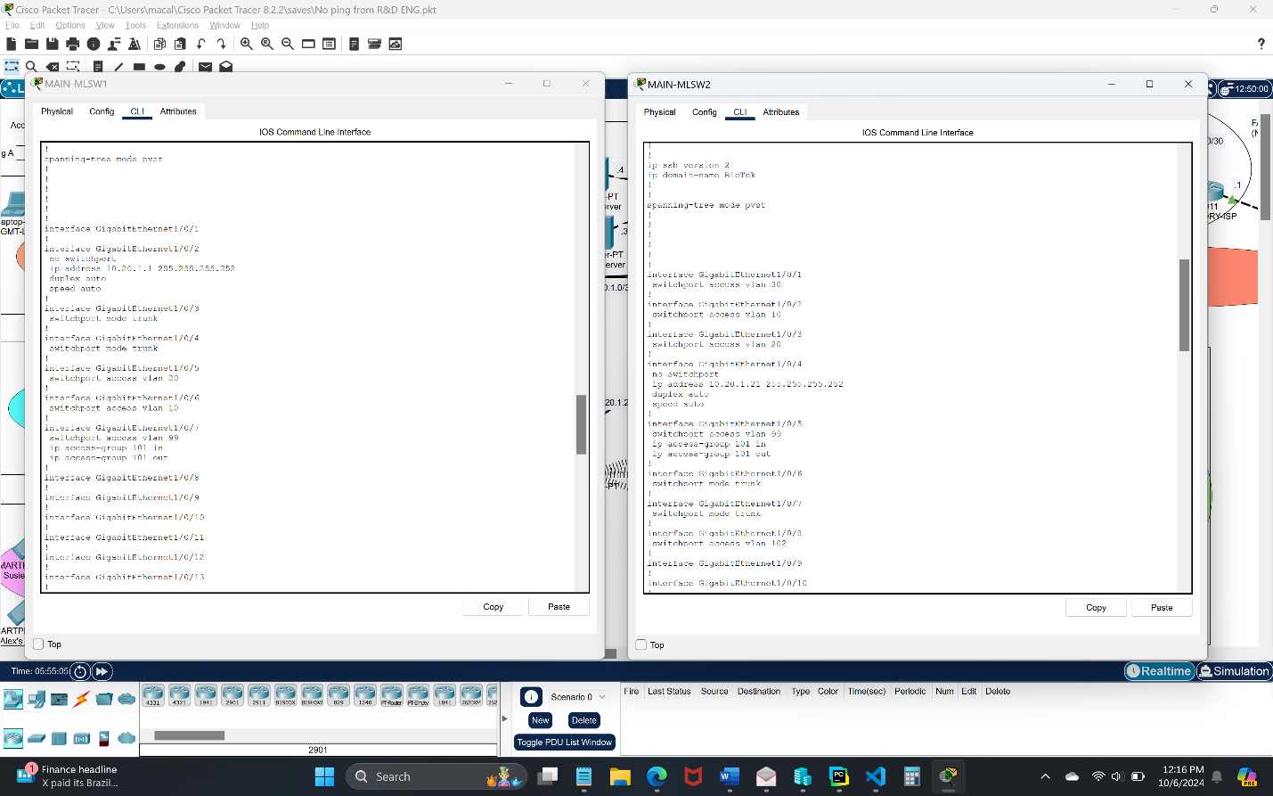Access Group 101 applied to interfaces connected to the Guest Department for security, g1/0/7 on MLSW1 and g1/0/5 on MLSW2:*

# Test Case #3: Security Compliance—Log-in Banners

*Display a log-in banner when accessing each device on the network. The log-in banner should notify users of an acceptable use policy (AUP) or other security-based policies when attempting to log into the network.*

## Functionality

*Describe the* ***functionality*** *of the test case in relation to your network project. Identify the relevant tools (devices, subnets, etc.) used in this test case and their specific interactions.*

Every networking device within the topology has been configured with a log-in banner to inform users of an AUP and security related functions that are authorized only to specific personnel. The outside routers have been configured with a different banner from all the internal devices because they are not owned by BioTek Co and therefore have a different login banner that cautions of different security policies.

**Functionality:** When first attempting to enter any networking device there should be a banner that is displayed to inform the user of the specific AUP regarding use of the device before using the "enable" command.

## Network Diagram or Segment

*Provide a* ***network diagram or segment*** *visualizing the topology and devices used in this test case.*



## Testing Method

*Summarize the* ***testing method*** *used to verify functionality of the network project within the virtual lab environment, including any metrics of success.*

**Testing:** To test the functionality of my new banners I had to ensure I was out of global and privileged exec modes and into user mode by using the "exit" command. After seeing a fresh CLI terminal I hit the enter key to get ready to input the "enable" command to enter privileged exec mode. Before using the "enable" command my banner message appeared right above the terminal line to inform the user of the AUP for the device which verified proper functionality.

## Process List

*Provide a comprehensive* ***process list*** *of the steps taken within the network project to run the testing method. Include screenshots to illustrate the process and ensure clarity for others attempting to replicate the test.*

**Steps**: To setup the banners I had to go into configuration mode in the CLI of each device and enter the following command, "banner motd $Warning! This is a private system. Unauthorized access to or use of this system is strictly prohibited. By continuing, you acknowledge your awareness of and concurrence with the Acceptable Use Policy of Biotek Manufacturing Co.$". Due to the scenario, on the routers I used a different message which was a result of the following similar commands:

MAIN-ISP:

banner motd $WARNING! AUTHORIZED USE ONLY! Property of MontereyISP. Unauthorized use of this device will be punished up to the full extent of the Law.$

INTERNET:

banner motd $WARNING! AUTHORIZED USE ONLY! Property of DistributedISP. Unauthorized use of this device will be punished up to the full extent of the Law.$

FACTORY-ISP:

banner motd $WARNING! AUTHORIZED USE ONLY! Property of SantaCruzISP. Unauthorized use of this device will be punished up to the full extent of the Law.$

Screenshots for Test Case 3:

*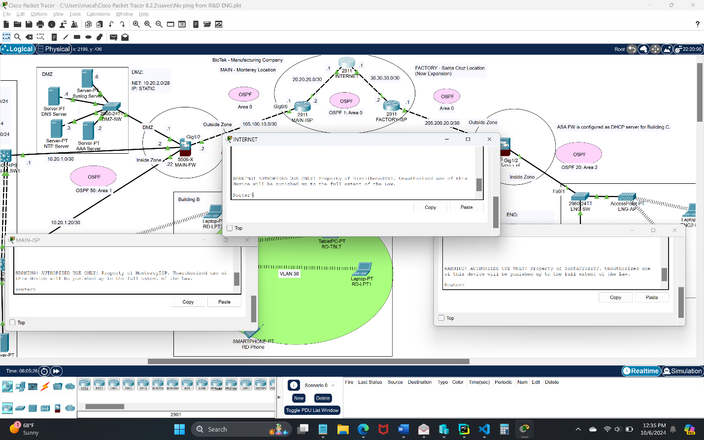Configuration of the Banners on each networking device in the Monterey Location including the MGMT-SW, IT-SW, Guest-SW, MLSW1, and MLSW2:*

*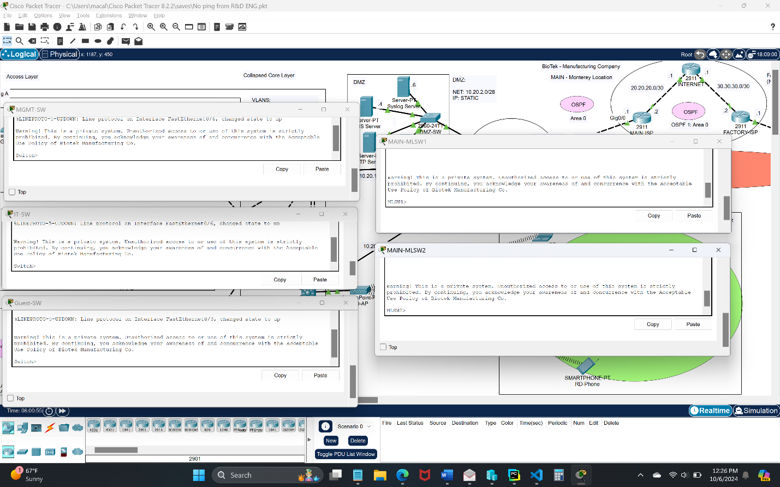Configuration of the Banners on each of the routers including the MAIN-ISP, INTERNET, FACTORY-ISP:*

# Test Case #4: Accessing External Resources—Routing and Traffic Security

*User devices on your network should have dynamic addresses that are assigned through DHCP unless they provide a service that requires a static address. You must also have at least one network resource that requires a static address.*

## Functionality

*Describe the* ***functionality*** *of the test case in relation to your network project. Identify the relevant tools (devices, subnets, etc.) used in this test case and their specific interactions.*

 The DMZ in Building A houses 4 servers that have all been assigned static IP addresses. Due to the limitations of packet tracer, I was unable to setup DHCP relay on the ASA-FWs and moved my DHCP server outside the DMZ to the internal network and connected it directly to MLSW2 with a static IP address on VLAN 102. Once relocated I was able to setup DHCP relay on the Core MLSWs to provide specific IP ranges to each VLAN that corresponded to each department. Static IP addresses were setup between the core MLSWs and MAIN-FW. Static IP addresses were also configured between all outside devices and with a /30 mask between each device. Building C in the Santa Cruz location does not have an internal DHCP server because it is still in the transition phase of development. To address this, I established the Santa Cruz Firewall to distribute DHCP addresses to the Engineering department. In addition, all wireless devices will need to be configured to the appropriate SSID that is configured on their corresponding Access Points. I’ve replaced the wireless laptops custom module with a WPC300N to connect to the WAPs.

**Functionality**: The MGMT (192.168.1.0/24), IT (192.168.2.0/24), Guest (192.168.99.0/24), and R&D (192.168.3.0/24) departments should all be receiving IP addresses from the DHCP server at 10.20.4.2. The ENG department (192.168.40.0/24) should be receiving IP addresses from the FACTORY-FW. All networking devices including servers, firewalls, routers, and core multi-layer-switches are configured with static IP addresses. The MLSWs have static IP addresses facing the MAIN-FW and DHCP on their VLANs that are facing the departments.

(Monterey) Static IP

MAIN-FW:

- g1/1 - 10.20.2.1 255.255.255.240 (DMZ)

- g1/2 - 105.100.10.2 255.255.255.252 (Outside)

- g1/3 - 10.20.1.22 255.255.255.252 (Inside2)

- g1/4 - 10.20.1.2 255.255.255.252 (Inside)

Syslog Server:

- 10.20.2.6 255.255.255.240

DNS Server:

- 10.20.2.4 255.255.255.240

NTP Server:

- 10.20.2.3 255.255.255.240

AAA Server:

- 10.20.2.2 255.255.255.240

DHCP Server:

- 10.20.4.2 255.255.255.252

MAIN-MLSW1:

- g1/0/2 - 10.20.1.1 255.255.255.252

MAIN-MLSW2:

- g1/0/4 - 10.20.1.21 255.255.255.252

(Santa Cruz) Static IP

FACTORY-FW:

- g1/1 - 205.200.20.2 255.255.255.252 (Outside)

- g1/2 - 192.168.40.1 255.255.255.0 (Inside)

(Outside routers) Static IP

INTERNET:

- g0/0 - 20.20.20.1 255.255.255.252

- g0/1 - 30.30.30.1 255.255.255.252

MAIN-ISP:

- g0/0 - 105.100.10.1 255.255.255.252

- g0/1 - 20.20.20.2 255.255.255.252

FACTORY-ISP:

- g0/0 - 30.30.30.2 255.255.255.252

- g0/1 - 205.200.20.1 255.255.255.252

(Monterey) DHCP IP - received from DHCP Server

MGMT Department (VLAN 10):

- 192.168.1.0 255.255.255.0

IT Department (VLAN 20):

- 192.168.2.0 255.255.255.0

R&D Department (VLAN 30):

- 192.168.3.0 255.255.255.0

Guest Department (VLAN 99):

- 192.168.99.0 255.255.255.0

(Santa Cruz) DHCP IP - received from FACTORY-FW

ENG Department:

- 192.168.40.0 255.255.255.252

## Network Diagram or Segment

*Provide a* ***network diagram or segment*** *visualizing the topology and devices used in this test case.*



## Testing Method

*Summarize the* ***testing method*** *used to verify functionality of the network project within the virtual lab environment, including any metrics of success.*

**Testing**: To test functionality of my newly implemented static and DHCP addresses I could hover over the devices in packet tracer to see the correct IP information for end devices as well as going into the Desktop tab --> Command Prompt and use the command: "ipconfig /all" to see all relevant IP information. Next to ensure connectivity I went into MAIN-MLSW2 and attempted to ping an end device in each department in the Monterey location with the command, "ping 192.168.X.X". In the Santa Cruz location, I used the same ping command but for a device with an IP in its range.

## Process List

*Provide a comprehensive* ***process list*** *of the steps taken within the network project to run the testing method. Include screenshots to illustrate the process and ensure clarity for others attempting to replicate the test.*

**Steps**: The steps for setting up the Static IP addresses for the servers consisted of navigating through the tabs and entering the correct information detailed further below. Setting up the static IPs on all other devices involved configuring the correct interface and using the commands as specified below for each device. After the Static IP addresses were set, I went into the DHCP Server --> Services --> DHCP tab where I could enter the correct IP range for each department in the appropriate fields as seen in the screenshots. Next, I configured the FACTORY-FW as the DHCP server for the Santa Cruz location which required enabling DHCPD for the correct address range. After DHCP had been enabled and configured for the IP ranges, I went into every end device in both the Monterey and Santa Cruz locations and entered the Desktop tab --> IP configuration, where I could turn on the DHCP service. This step had to be done for every end device. Ensuring that the wireless devices received IPs from the correct AP I established a connection to individual SSID's on each wireless device in the departments with WPA2-PSK security to the correct SSID to ensure that the wireless devices were receiving IP addresses in the correct range for their department.

Static IP configurations

MAIN-FW:

int g1/1

ip address 10.20.2.1 255.255.255.240 (DMZ)

int g1/2

ip address 105.100.10.2 255.255.255.252 (Outside)

int g1/3

ip address 10.20.1.22 255.255.255.252 (Inside2)

int g1/4

ip address 10.20.1.2 255.255.255.252 (Inside)

MAIN-MLSW1:

int g1/0/2

ip add 10.20.1.1 255.255.255.252

MAIN-MLSW2:

int g1/0/4

ip add 10.20.1.21 255.255.255.252

FACTORY-FW:

int g1/1

ip add 205.200.20.2 255.255.255.252 (Outside)

int g1/2

ip add 192.168.40.1 255.255.255.0 (Inside)

INTERNET:

int g0/0

ip add 20.20.20.1 255.255.255.252

int g0/1

ip add 30.30.30.1 255.255.255.252

MAIN-ISP:

int g0/0

ip add 105.100.10.1 255.255.255.252

int g0/1

ip add 20.20.20.2 255.255.255.252

FACTORY-ISP:

int g0/0

ip add 30.30.30.2 255.255.255.252

int g0/1

ip add 205.200.20.1 255.255.255.252

Monterey location DHCP configurations

MAIN-MLSW1:

int vlan 10

ip helper-address 10.20.4.2

int vlan 20

ip helper-address 10.20.4.2

int vlan 99

ip helper-address 10.20.4.2

MAIN-MLSW2:

int vlan 10

ip helper-address 10.20.4.2

int vlan 20

ip helper-address 10.20.4.2

int vlan 30

ip helper-address 10.20.4.2

int vlan 99

ip helper-address 10.20.4.2

FACTORY-FW DHCP configuration

FACTORY-FW:

dhcpd address 192.168.40.2-192.168.40.254 INSIDE

dhcpd dns 10.20.2.4

dhcpd enable INSIDE

Screenshots for Test Case 4:

*Configuration of the Static IP addresses for Syslog, DNS, NTP, AAA, and DHCP Servers in the Monterey location:*

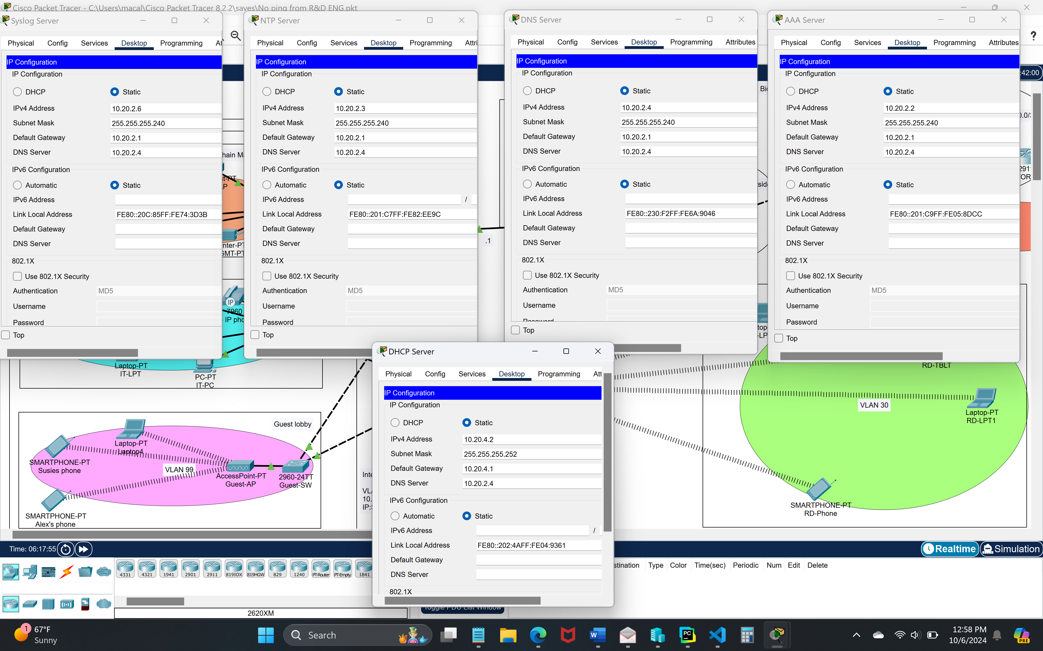

*Configuration of the Static IP addresses on MLSW1 and MLSW2 in the Monterey location:*

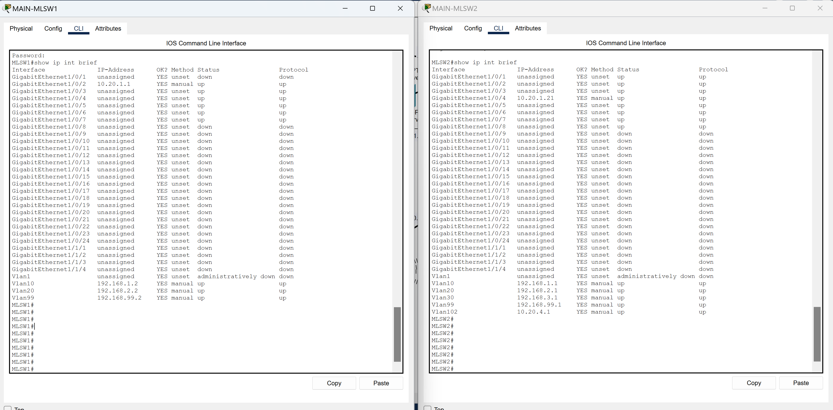

*Configuration of the Static IP addresses on the MAIN-FW in the Monterey location and the FACTORY-FW in the Santa Cruz location:*

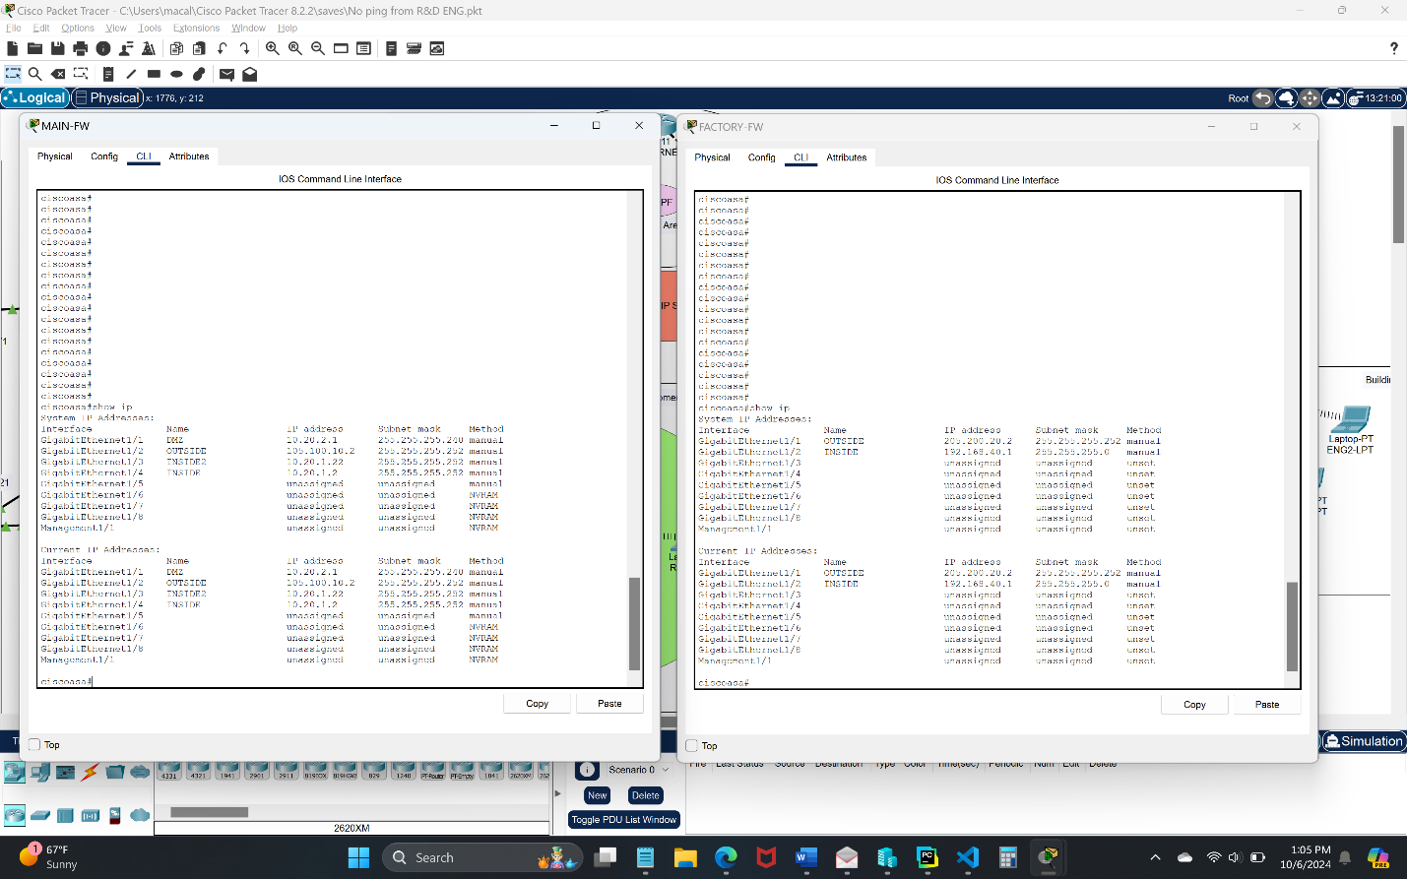

*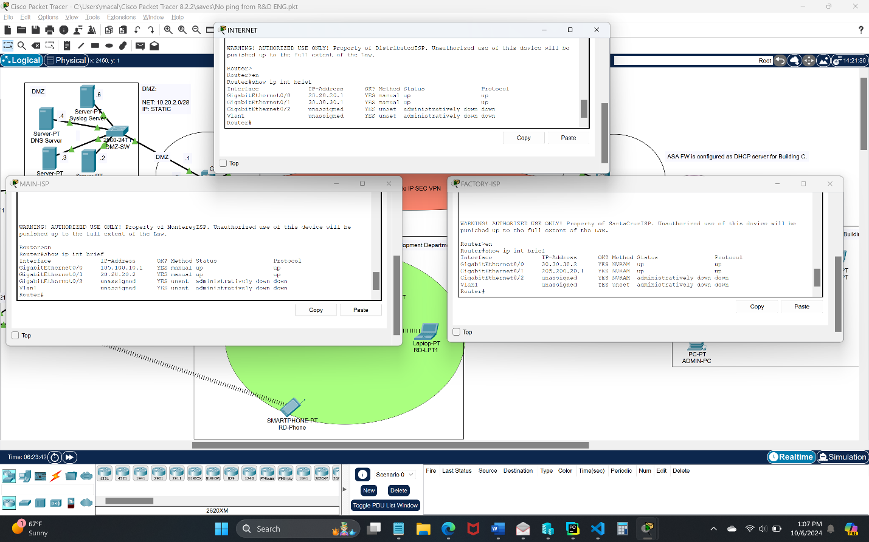Configuration of the Static IP addresses for the MAIN-ISP, INTERNET, and FACTORY-ISP routers:*

*Configuration of the DHCP server: 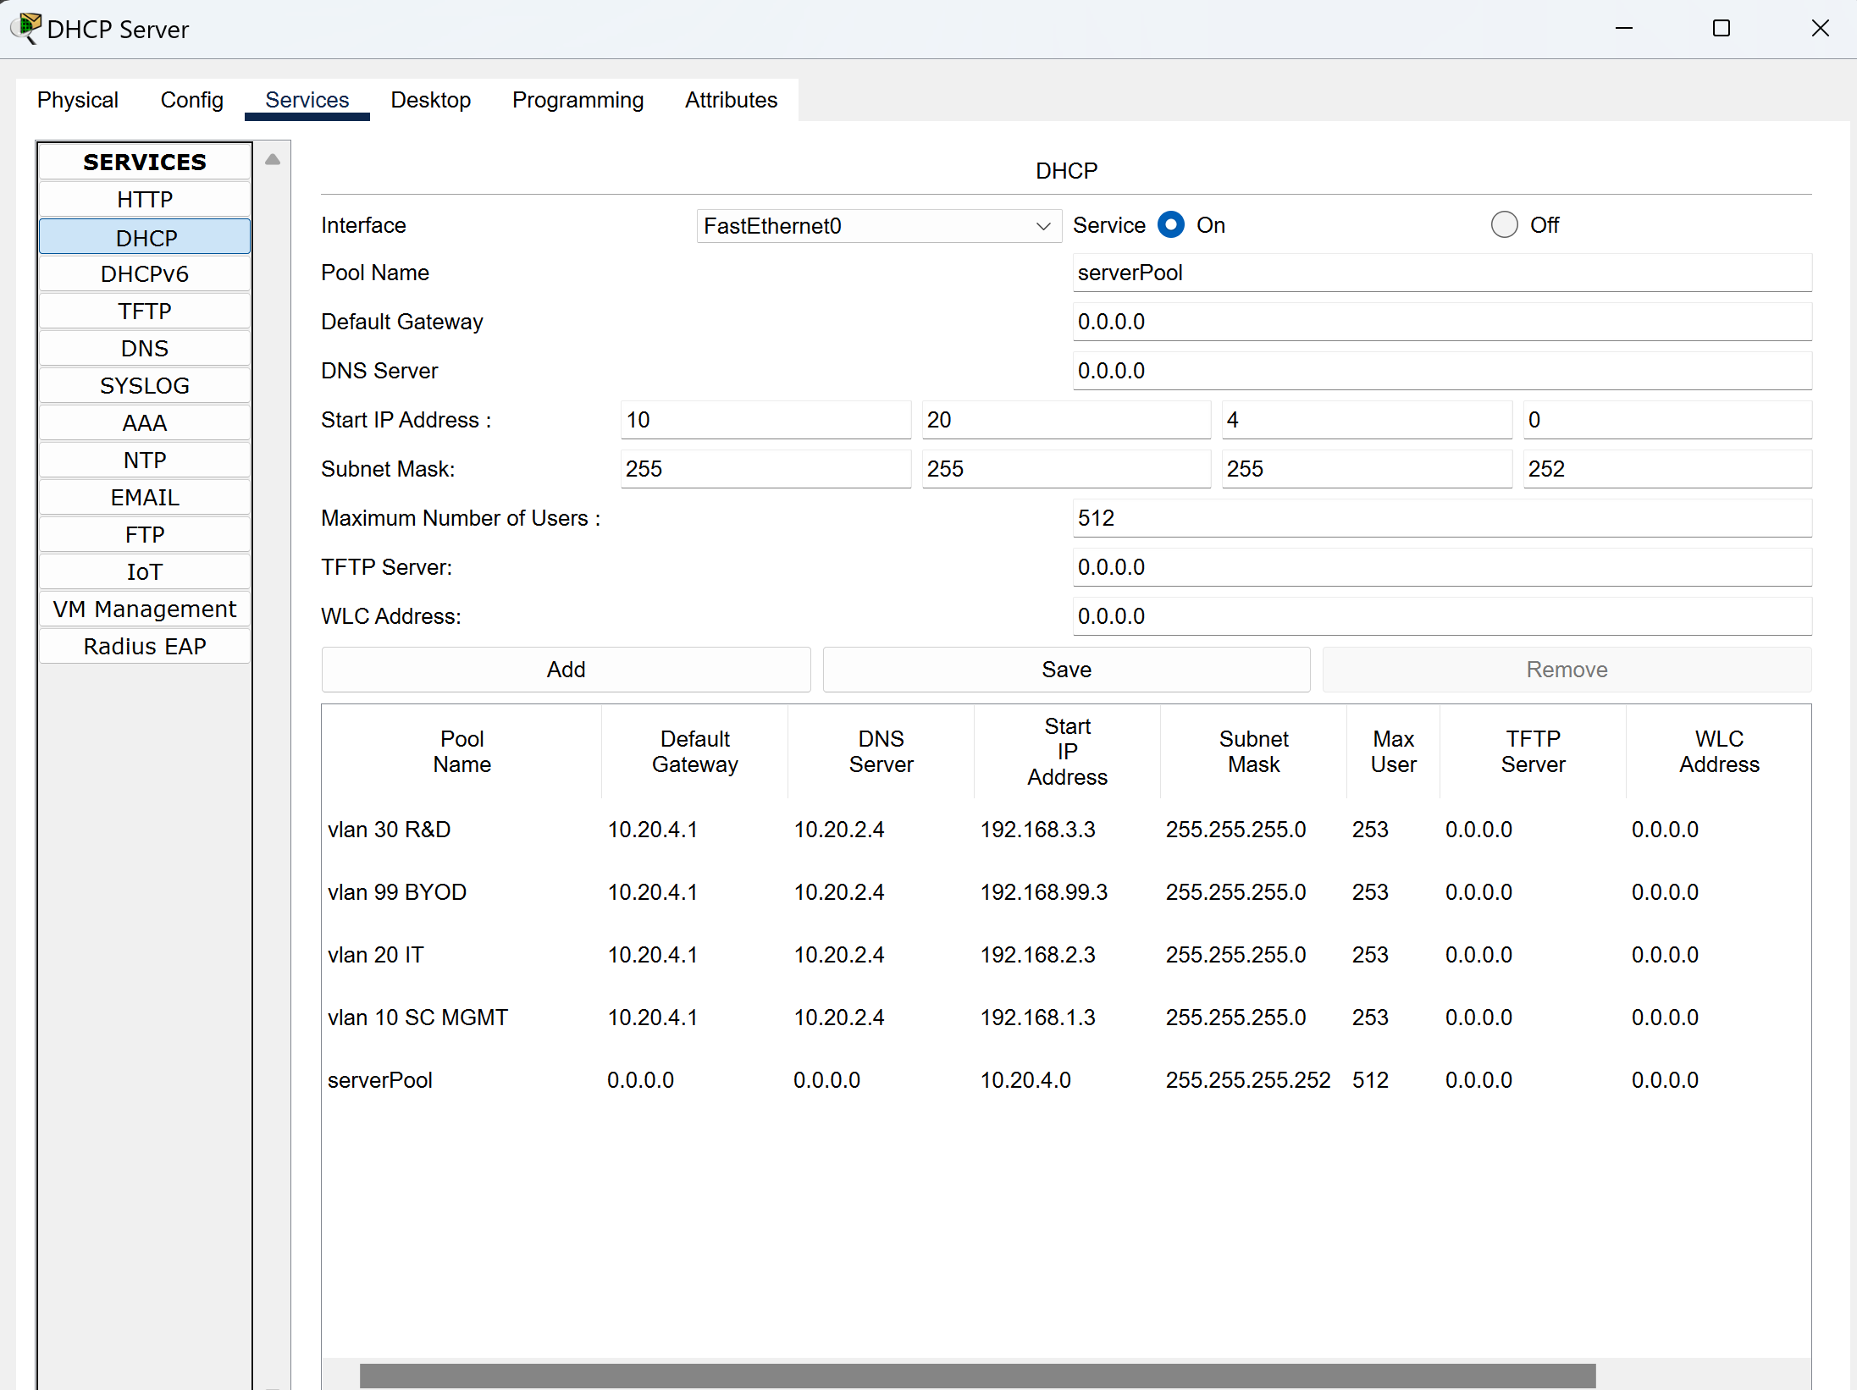*

*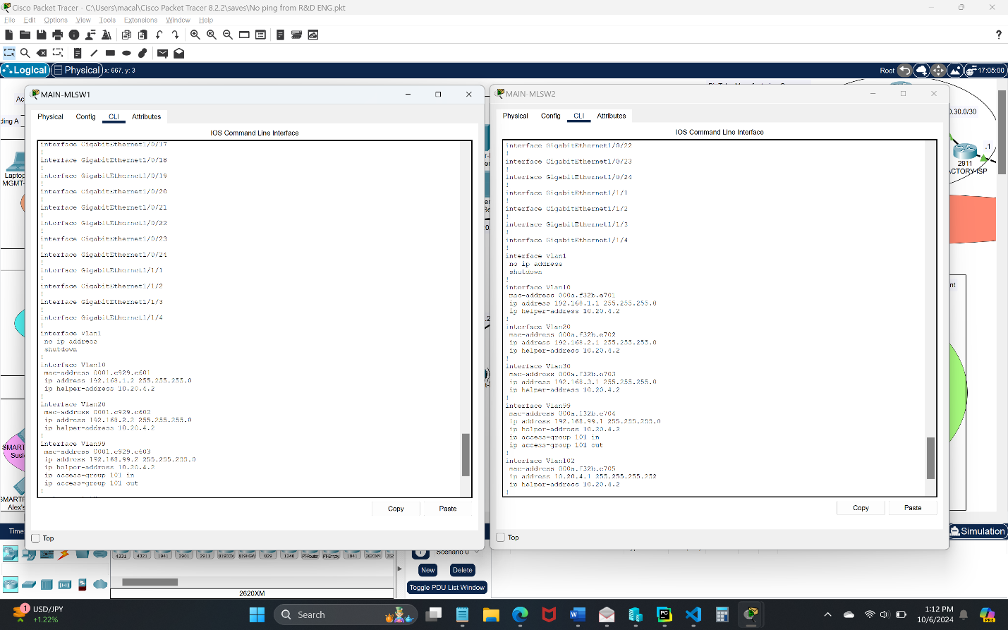Configuration of the DHCP helper address configurations on MLSW1 and MLSW2:*

*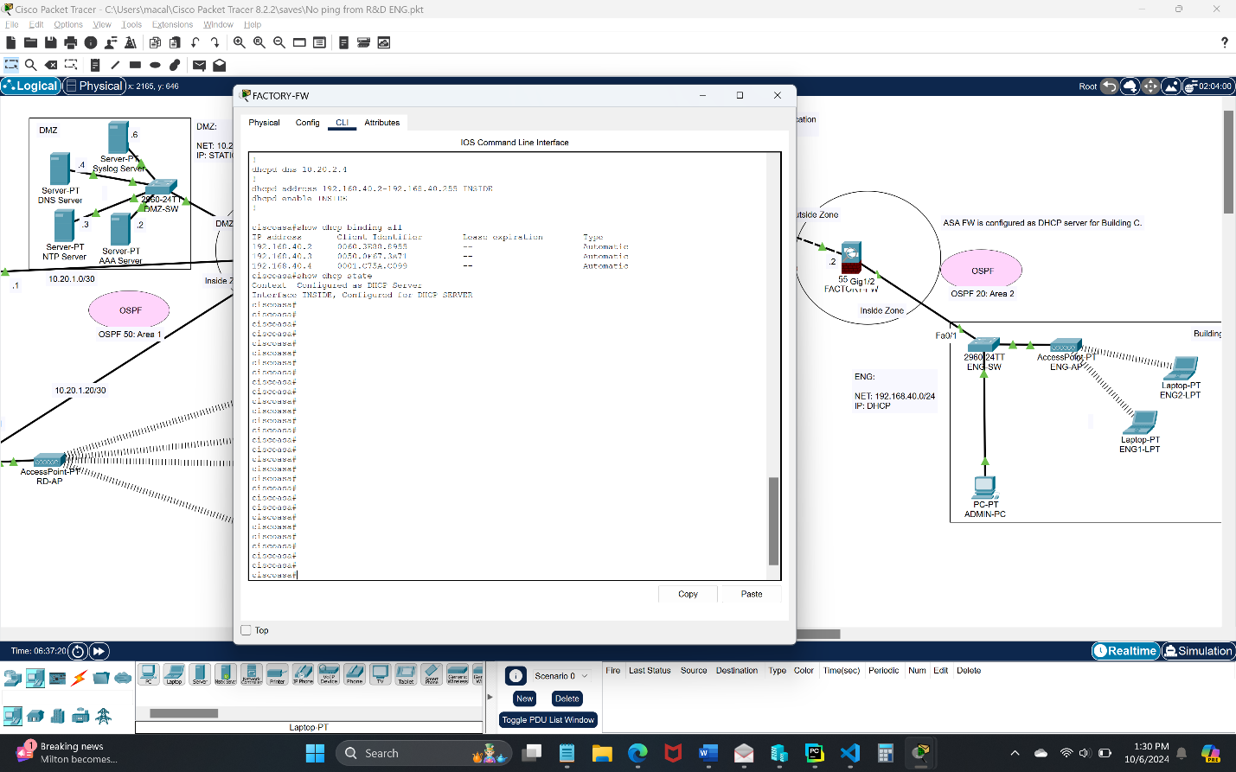Configuration for setting the FACTORY-FW as a DHCP server for the ENG department:*

# Test Case #5: Layer 2 Link Redundancy and Spanning Tree Protocol (802.1w)

*Enable and manage the Spanning Tree Protocol to establish redundant Layer 2 paths while avoiding possible loops and broadcast storms. Identify the Layer 2 devices that will become the root bridge.*

## Functionality

*Describe the* ***functionality*** *of the test case in relation to your network project. Identify the relevant tools (devices, subnets, etc.) used in this test case and their specific interactions.*

To establish redundancy in my topology I created two MLSW's that serve as a Collapsed Core with link redundancy between them and are connected to a L2 SW in each department. MLSW1 serves as the root bridge for VLANs 1 and 10, while MLSW2 serves as the root bridge for VLANs 30 and 102. On MLSW1 g1/0/5 is the root for VLAN 20 and g1/0/7 is the root for VLAN 99. On MLSW2 g1/0/3 is the root for VLAN 20 and g1/0/5 is the root for VLAN 99.

**Functionality**: After connecting all the switches with the correct configurations, I should see in my topology a link turn orange instead of green in packet tracer. To assure that spanning-tree is working properly I would also need to verify that a BLK status was present on one of the links.

## Network Diagram or Segment

*Provide a* ***network diagram or segment*** *visualizing the topology and devices used in this test case.*

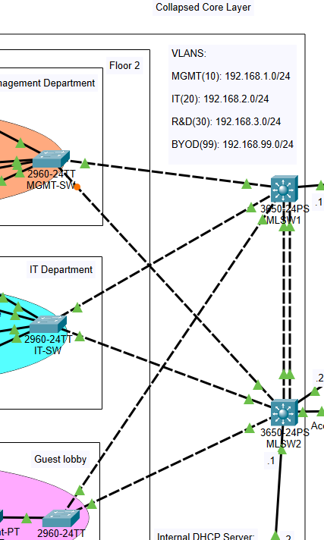

## Testing Method

*Summarize the* ***testing method*** *used to verify functionality of the network project within the virtual lab environment, including any metrics of success.*

**Testing**: To verify STP functionality I went into the devices CLI and use the command, "show spanning". This command displays the STP stats for each interface as seen below. The spanning tree configurations verify current root bridges and blocked links to prevent broadcast storms.

## Process List

*Provide a comprehensive* ***process list*** *of the steps taken within the network project to run the testing method. Include screenshots to illustrate the process and ensure clarity for others attempting to replicate the test.*

**Steps**: The steps for setting up STP in my topology consisted of connecting three separate switches with cables. I have two main core MLSW's that have link redundancy between them and are both connecting to all other switches in the MGMT, IT, and Guest departments. After establishing redundant paths, I could visually see in packet tracer that my Fa0/1 link interface on my MGMT Switch had turned orange which is what I was expecting.

Screenshots for Test Case 5:

*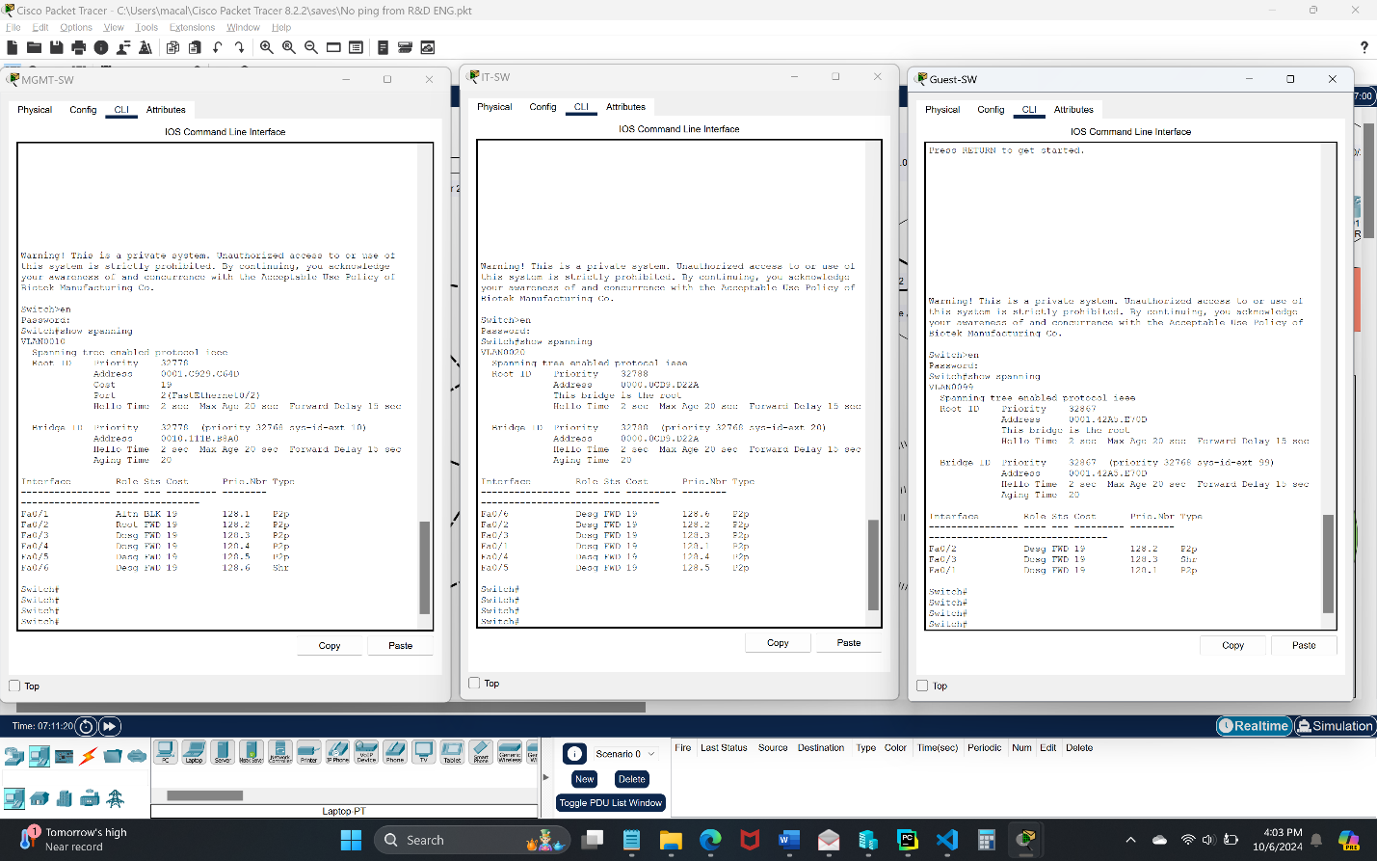STP Configuration on each department switch including MGMT-SW, IT-SW, and Guest-SW:*

*STP Configuration on MLSW1:*

*STP Configuration on MLSW1:*

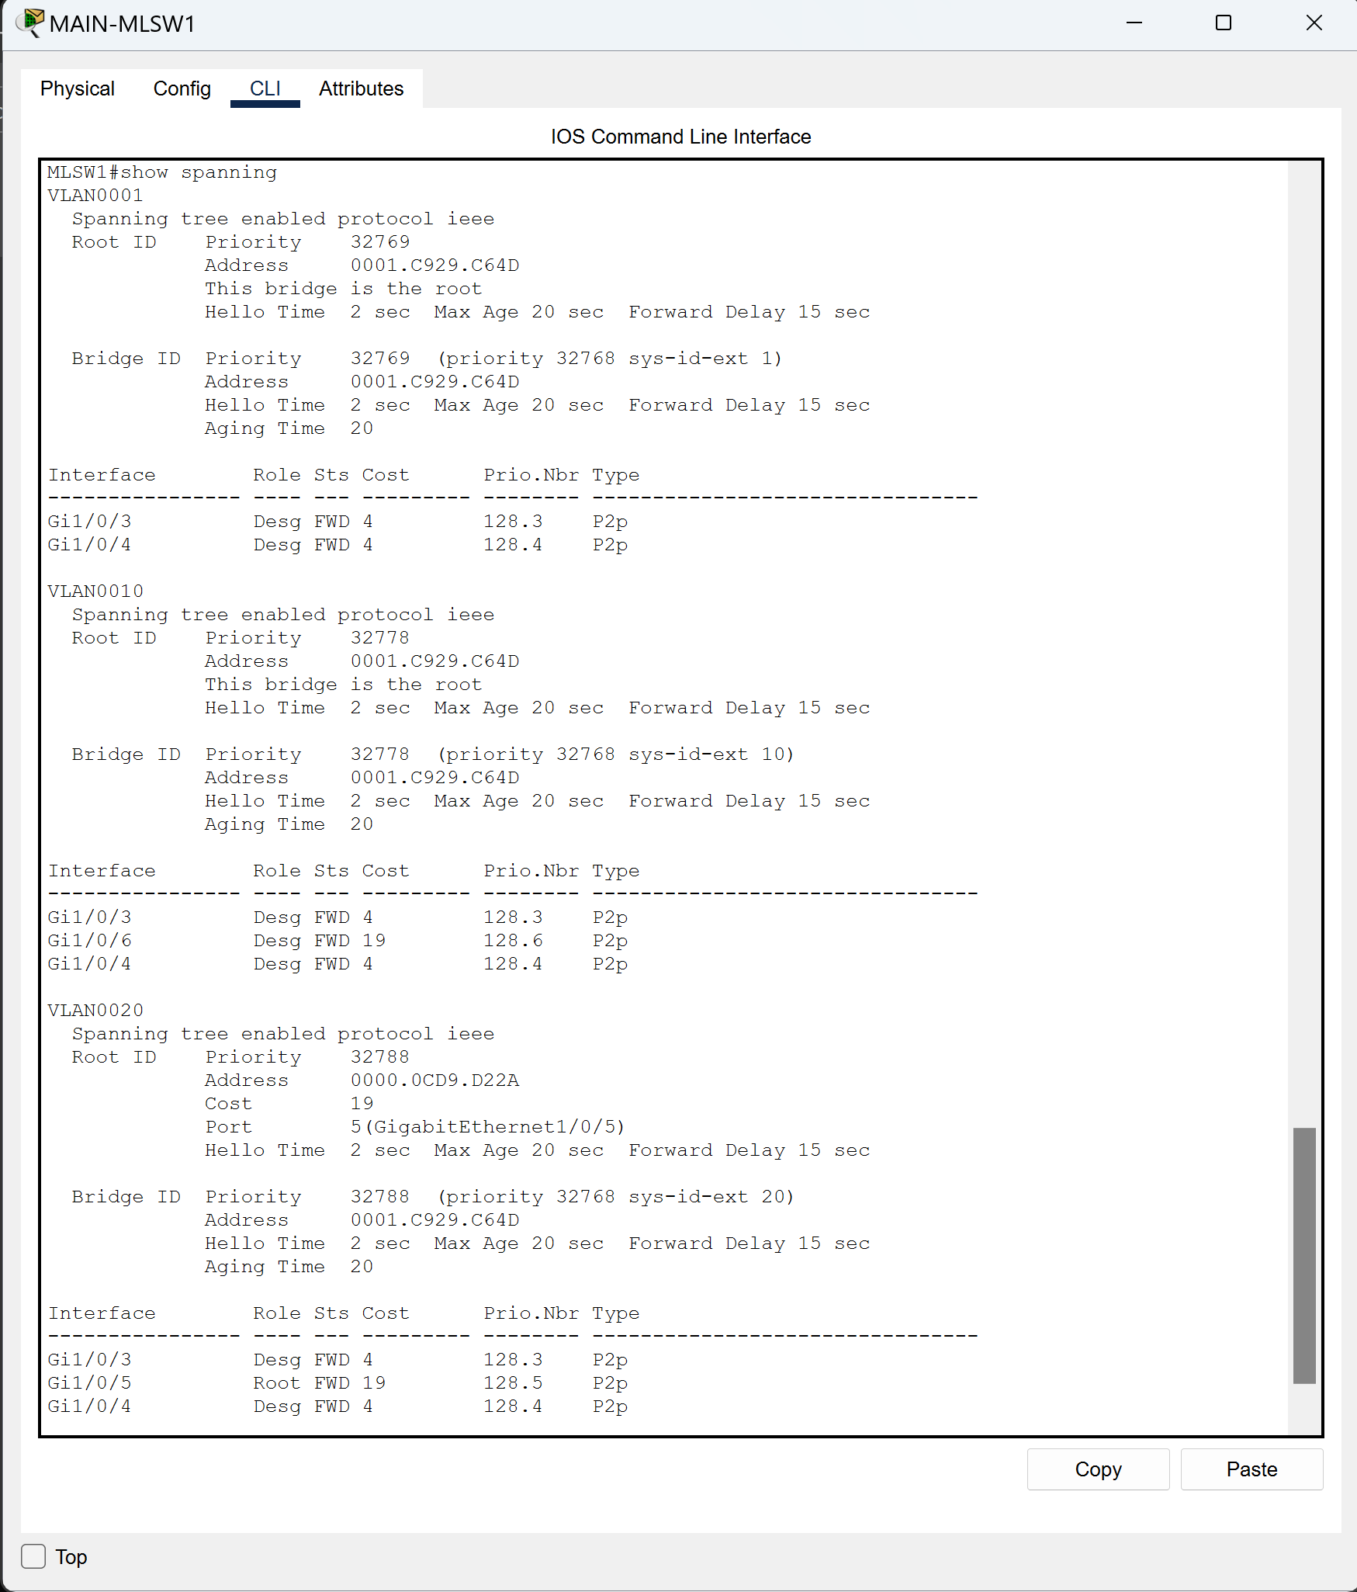

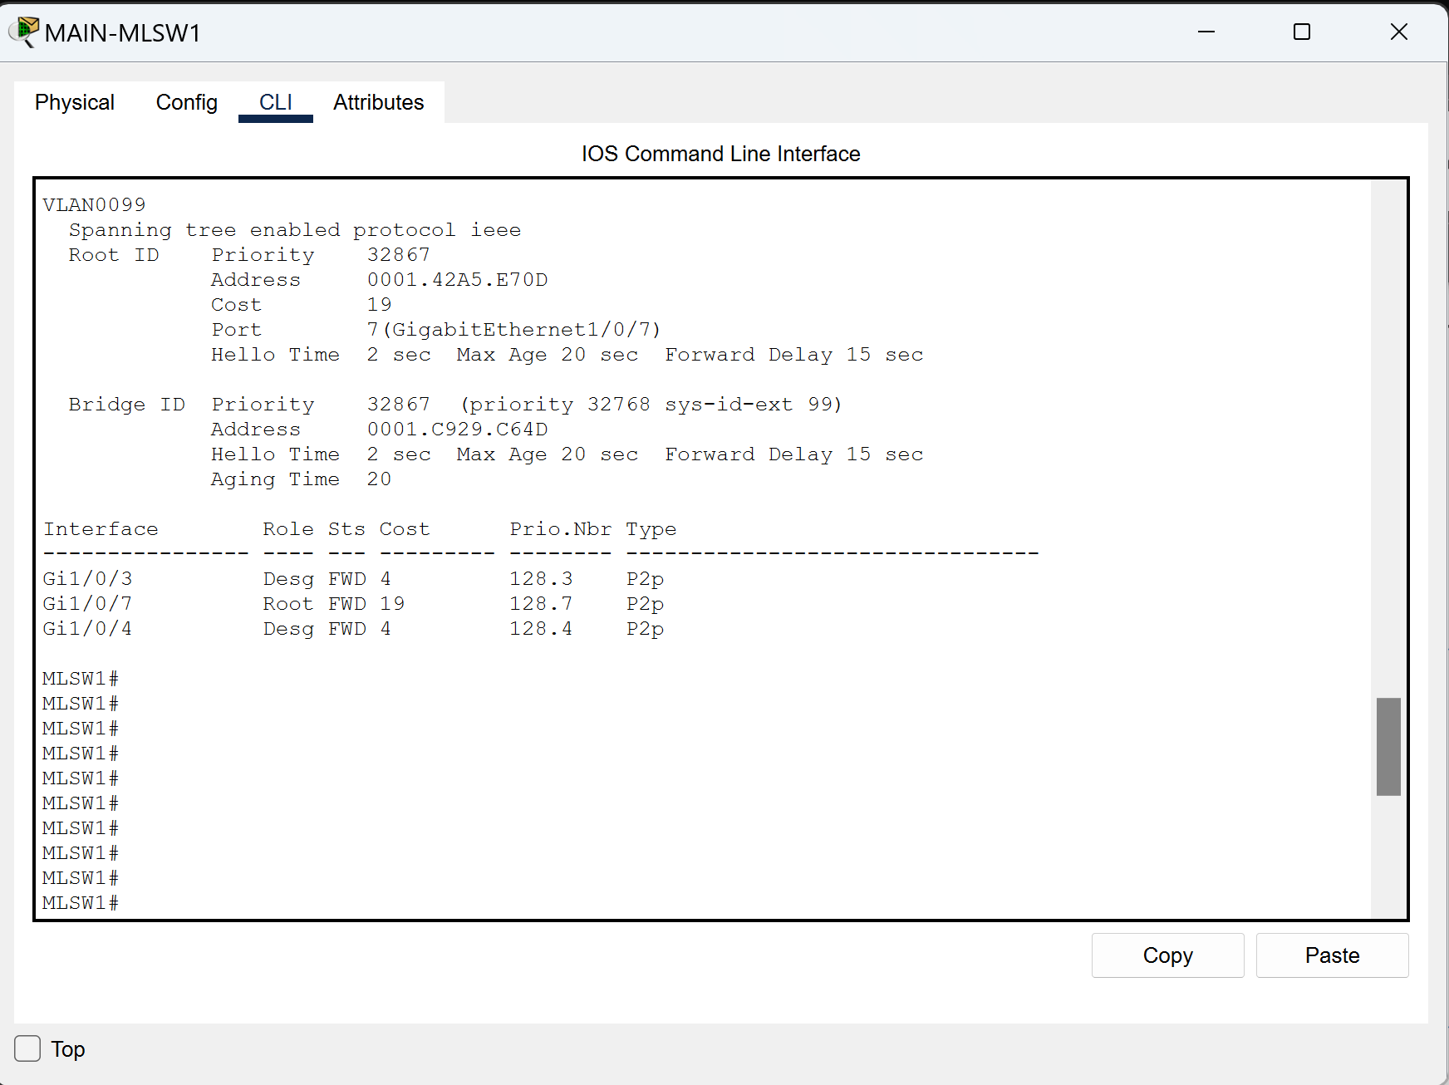

*STP Configuration on MLSW2:*

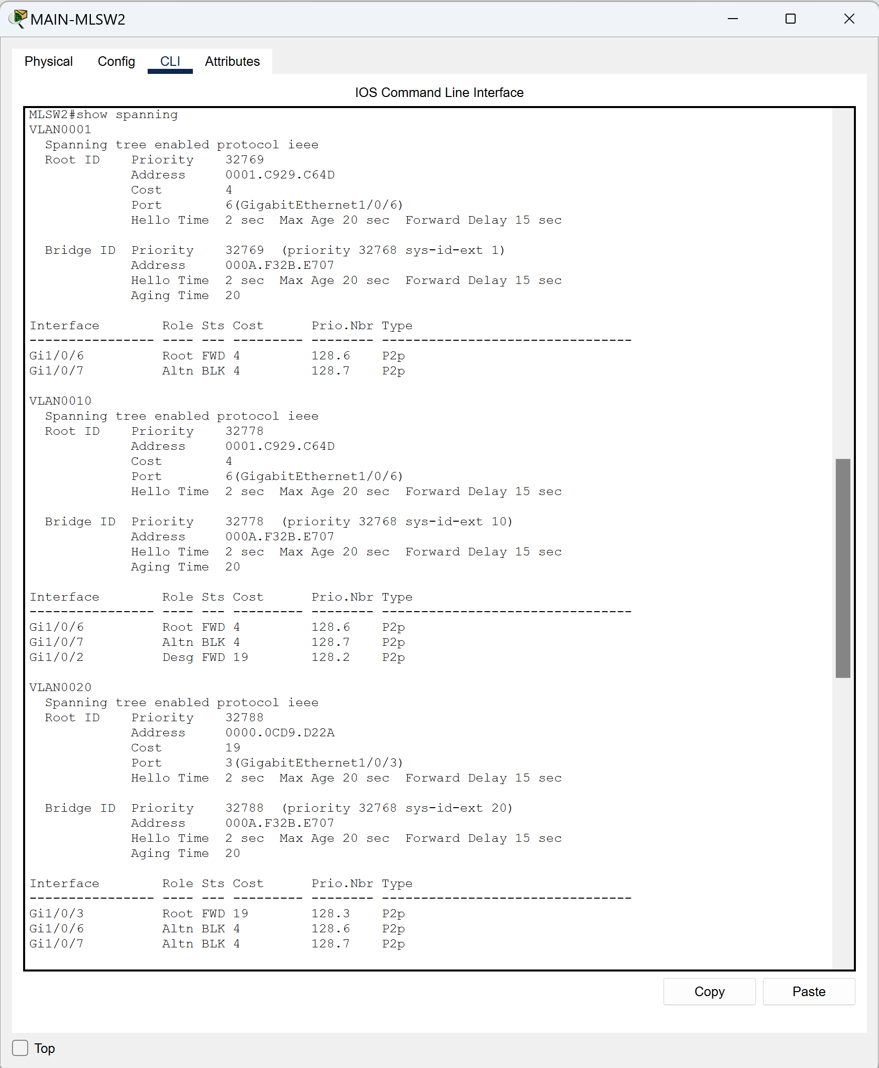

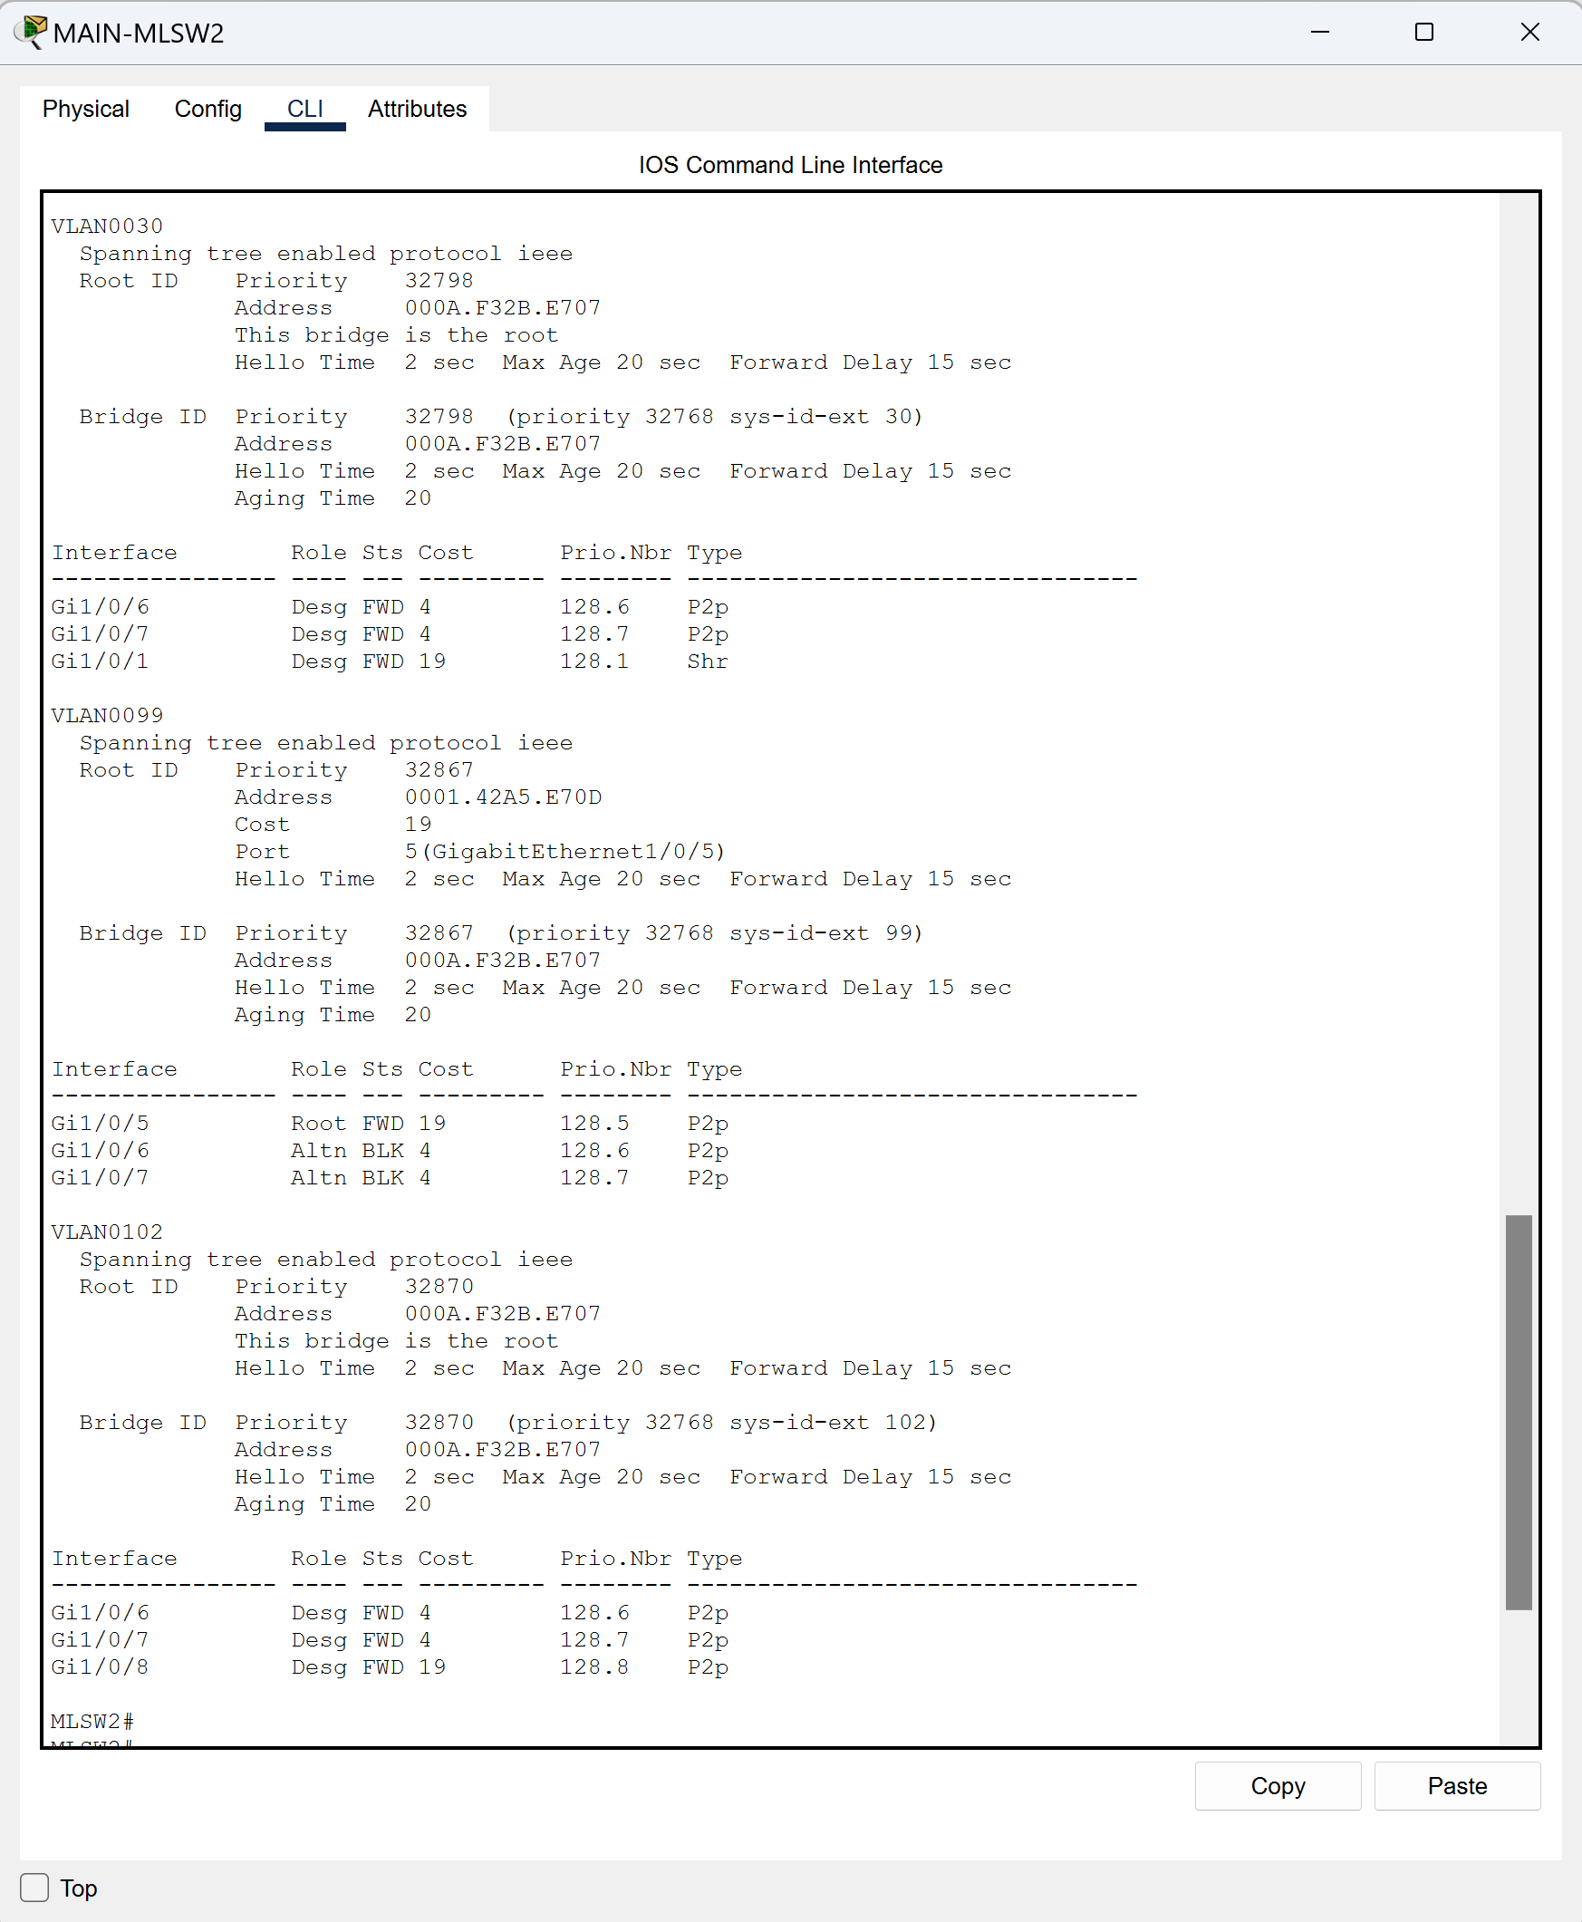

# Test Case #6: Edge Device Syslog and NTP

*Configure perimeter devices to generate system logs that capture unwanted traffic. Additionally, those perimeter devices should utilize Network Time Protocol (NTP) for clock synchronization.*

## Functionality

*Describe the* ***functionality*** *of the test case in relation to your network project. Identify the relevant tools (devices, subnets, etc.) used in this test case and their specific interactions.*

The Syslog server that centralizes log information is located inside the DMZ for enhanced security. Due to the limitations of Packet Tracer, I was unable to relay syslog information to the Syslog server on the ASA Firewalls so it will only collect information from the Monterey location due to the early expansion of Building C not yet having a MLSW. In building A, logs that take place on MLSW1 and MLSW2 point to the Syslog server in the DMZ to centrally store all their logging information. I have established a separate NTP server inside the DMZ to have accurate timestamps for the logging information. Each device was setup with the same timestamp information to ensure that all logging is the same on each device.

**Functionality**: I should be able to see new log information on the Syslog server located at 10.20.2.6 for an event that takes place on MLSW1 and MLSW2 that matches the timestamp that is configured on the NTP server at 10.20.2.3.

## Network Diagram or Segment

*Provide a* ***network diagram or segment*** *visualizing the topology and devices used in this test case.*

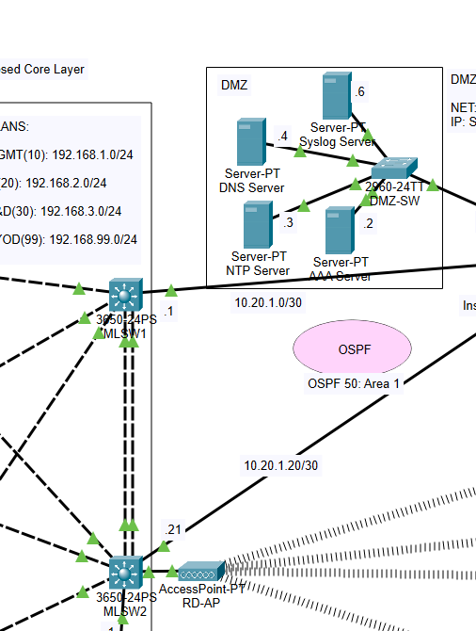

## Testing Method

*Summarize the* ***testing method*** *used to verify functionality of the network project within the virtual lab environment, including any metrics of success.*

**Testing**: To verify that I had successfully established logging to the syslog server I would first enter the commands "show logging" and "show ntp status" on each MLSW to see that the configurations are correct. I would then test this by interfacing g1/0/7 on MLSW2 and g1/0/2 on MLSW1 and entering the commands, "shut" and "noshut". This would log the link state into the syslog server which I was then able to verify by entering the ‘syslog’ services tab on the syslog server and seeing that the link information had been documented.

## Process List

*Provide a comprehensive* ***process list*** *of the steps taken within the network project to run the testing method. Include screenshots to illustrate the process and ensure clarity for others attempting to replicate the test.*

**Steps**: The first step was to setup the NTP server by going into the NTP services tab, turning the service on, clicking on the correct calendar date, and entering the time that I wanted configured. Next, I would configure the syslog server by going into the syslog services tab on the syslog server and turning the service on. Lastly, I needed to go into configuration mode on all networking devices in both locations and enter the command, "ntp server 10.20.2.3". On the MLSWs I entered the commands, "logging 10.20.2.6", and "logging on”. I also had to go into the ACLs that were created on the FWs to allow NTP traffic. The commands that I entered on each of the FWs to allow NTP traffic were "access-list VPN permit udp any any eq 123", "access-group VPN. On MAIN-FW I also entered "access-list RES permit udp any any eq 123" and on the FACTORY-FW I entered "access-list RES1 permit udp any any eq 123" and "access-group RES1 in interface OUTSIDE" to ensure that each ACL that I created allowed the NTP traffic.

Screenshots for Test Case 6:

*Service configuration on the Syslog and NTP Server:*

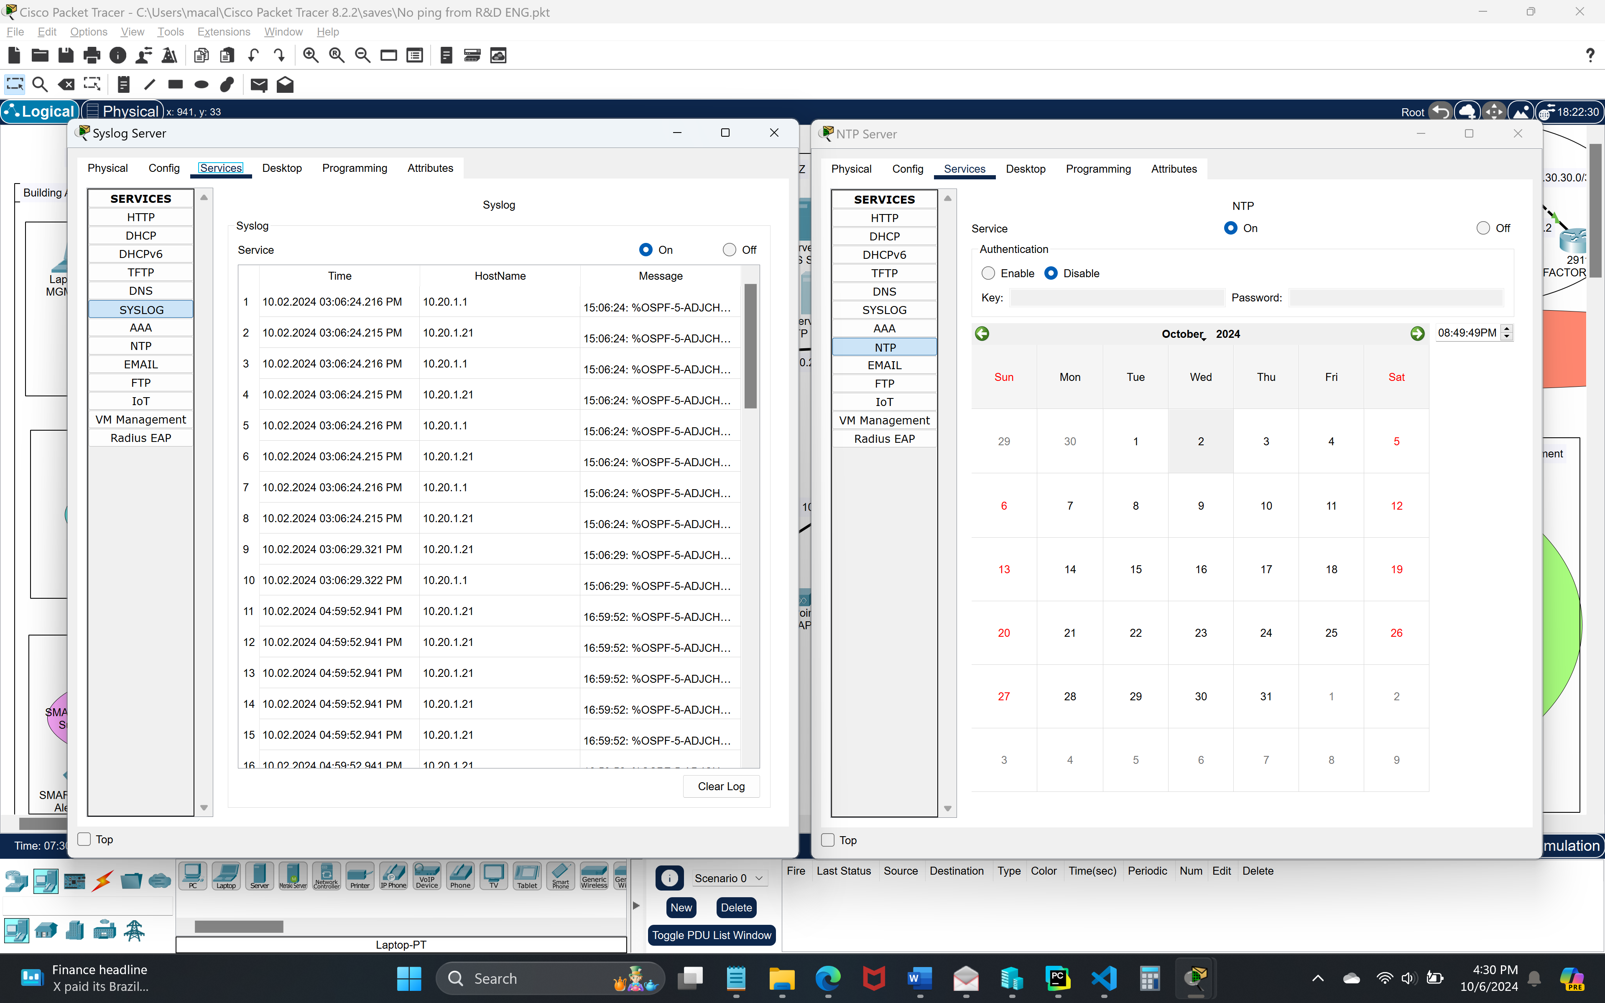

*NTP and Logging configurations on MLSW1 and MLSW2:*

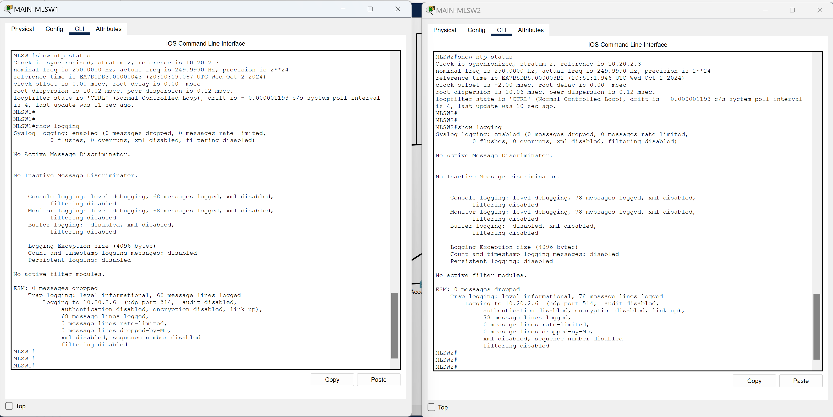

# Test Case #7: Basic Network Segmentation at Layer 2 via VLANs and 802.1q

*Your network traffic should be segmented per department or service function at Layer 2 to enhance security and reduce network congestion at the switching layer while allowing segmented traffic to traverse between switches (VLAN trunking).*

## Functionality

*Describe the* ***functionality*** *of the test case in relation to your network project. Identify the relevant tools (devices, subnets, etc.) used in this test case and their specific interactions.*

 Each department has been segmented via VLAN's with corresponding IP ranges applied to each VLAN from the DHCP server. All VLAN devices are connected to a MLSW through a L2 SW with exception of VLAN 102 which is connected straight to MLSW2. For the MLSW's to communicate outside the departments I’ve established trunking between the MLSWs, all other connected interfaces were configured with a VLAN or /30 subnet mask.

Due to the limitations of Packet Tracer, I was unable to setup VLANs on the FWs but in a real-world scenario I would have done so from the MAIN-FW to the DMZ as well as from the FACTORY-FW to the Engineering Department.

**Functionality**: I should be able to see the VLAN creation on each MLSW and the corresponding IP address range associated to each VLAN as well as having interconnectivity for communication between VLANs. All VLANs should be configured with appropriate names for their respective departments.

## Network Diagram or Segment

*Provide a* ***network diagram or segment*** *visualizing the topology and devices used in this test case.*



## Testing Method

*Summarize the* ***testing method*** *used to verify functionality of the network project within the virtual lab environment, including any metrics of success.*

**Testing**: To test if the VLANs had been created with the appropriate IP addresses I went into each device and used the "show vlan" and “show trunk” commands to display the relevant information. Due to my DHCP server already being configured to distribute the correct IP addresses, all I needed to do next was to verify connectivity between VLANS. By confirming connectivity, I went into a device in each department and was able to successfully ping a device in all other VLANs, with the exception of the Guest department on BYOD VLAN 99 as per the previous test cases. For example, from the Supply Chain Management Department on MGMT VLAN 10 I was able to send a successful ping from the MGMT-LP (192.168.1.5) to a device within the IT department on VLAN 20, the R&D department on VLAN 30, and the DHCP Server on VLAN102 although current IP configurations already verified DHCP connectivity.

## Process List

*Provide a comprehensive* ***process list*** *of the steps taken within the network project to run the testing method. Include screenshots to illustrate the process and ensure clarity for others attempting to replicate the test.*

**Steps**: VLANs would have to be configured to specific interfaces on each switch which was done by getting into configuration mode and enter the following commands to setup each VLAN on each MLSW and department SW:

MAIN-MLSW1:

vlan 10

name SCMGMT

int vlan 10

ip address 192.168.1.0 255.255.255.0

int g1/0/6

switchport access vlan 10

vlan 20

name IT

int vlan 20

ip address 192.168.2.0 255.255.255.0

int g1/0/5

switchport access vlan 20

vlan 99

name BYOD

int vlan 99

ip address 192.168.99.0 255.255.255.0

int g1/0/7

switchport access vlan 99

int 1/0/3

switchport

switchport mode trunk

int 1/0/4

switchport

switchport mode trunk

MAIN-MLSW2:

vlan 10

name SCMGMT

int vlan 10

ip address 192.168.1.0 255.255.255.0

int g1/0/3

switchport access vlan 10

vlan 20

name IT

int vlan 20

ip address 192.168.2.0 255.255.255.0

int g1/0/6

switchport access vlan 20

vlan 30

name R&D

int vlan 30

ip address 192.168.3.0 255.255.255.0

int g1/0/1

switchport access vlan 30

vlan 99

name BYOD

int vlan 99

ip address 192.168.99.0 255.255.255.0

int g1/0/5

switchport access vlan 99

vlan 102

name DHCP

int vlan 102

ip address 10.20.4.0 255.255.255.252

int g1/0/8

switchport access vlan 102

int 1/0/6

switchport

switchport mode trunk

int 1/0/7

switchport

switchport mode trunk

MGMT-SW:

Int range fa0/1-6

Switchport access vlan 10

IT-SW:

Int range fa0/1-6

Switchport access vlan 20

Guest-SW:

Int range fa0/1-6

Switchport access vlan 10

Screenshots for Test Case 7:

*VLAN and Trunking configurations on MLSW1 and MLSW2:*

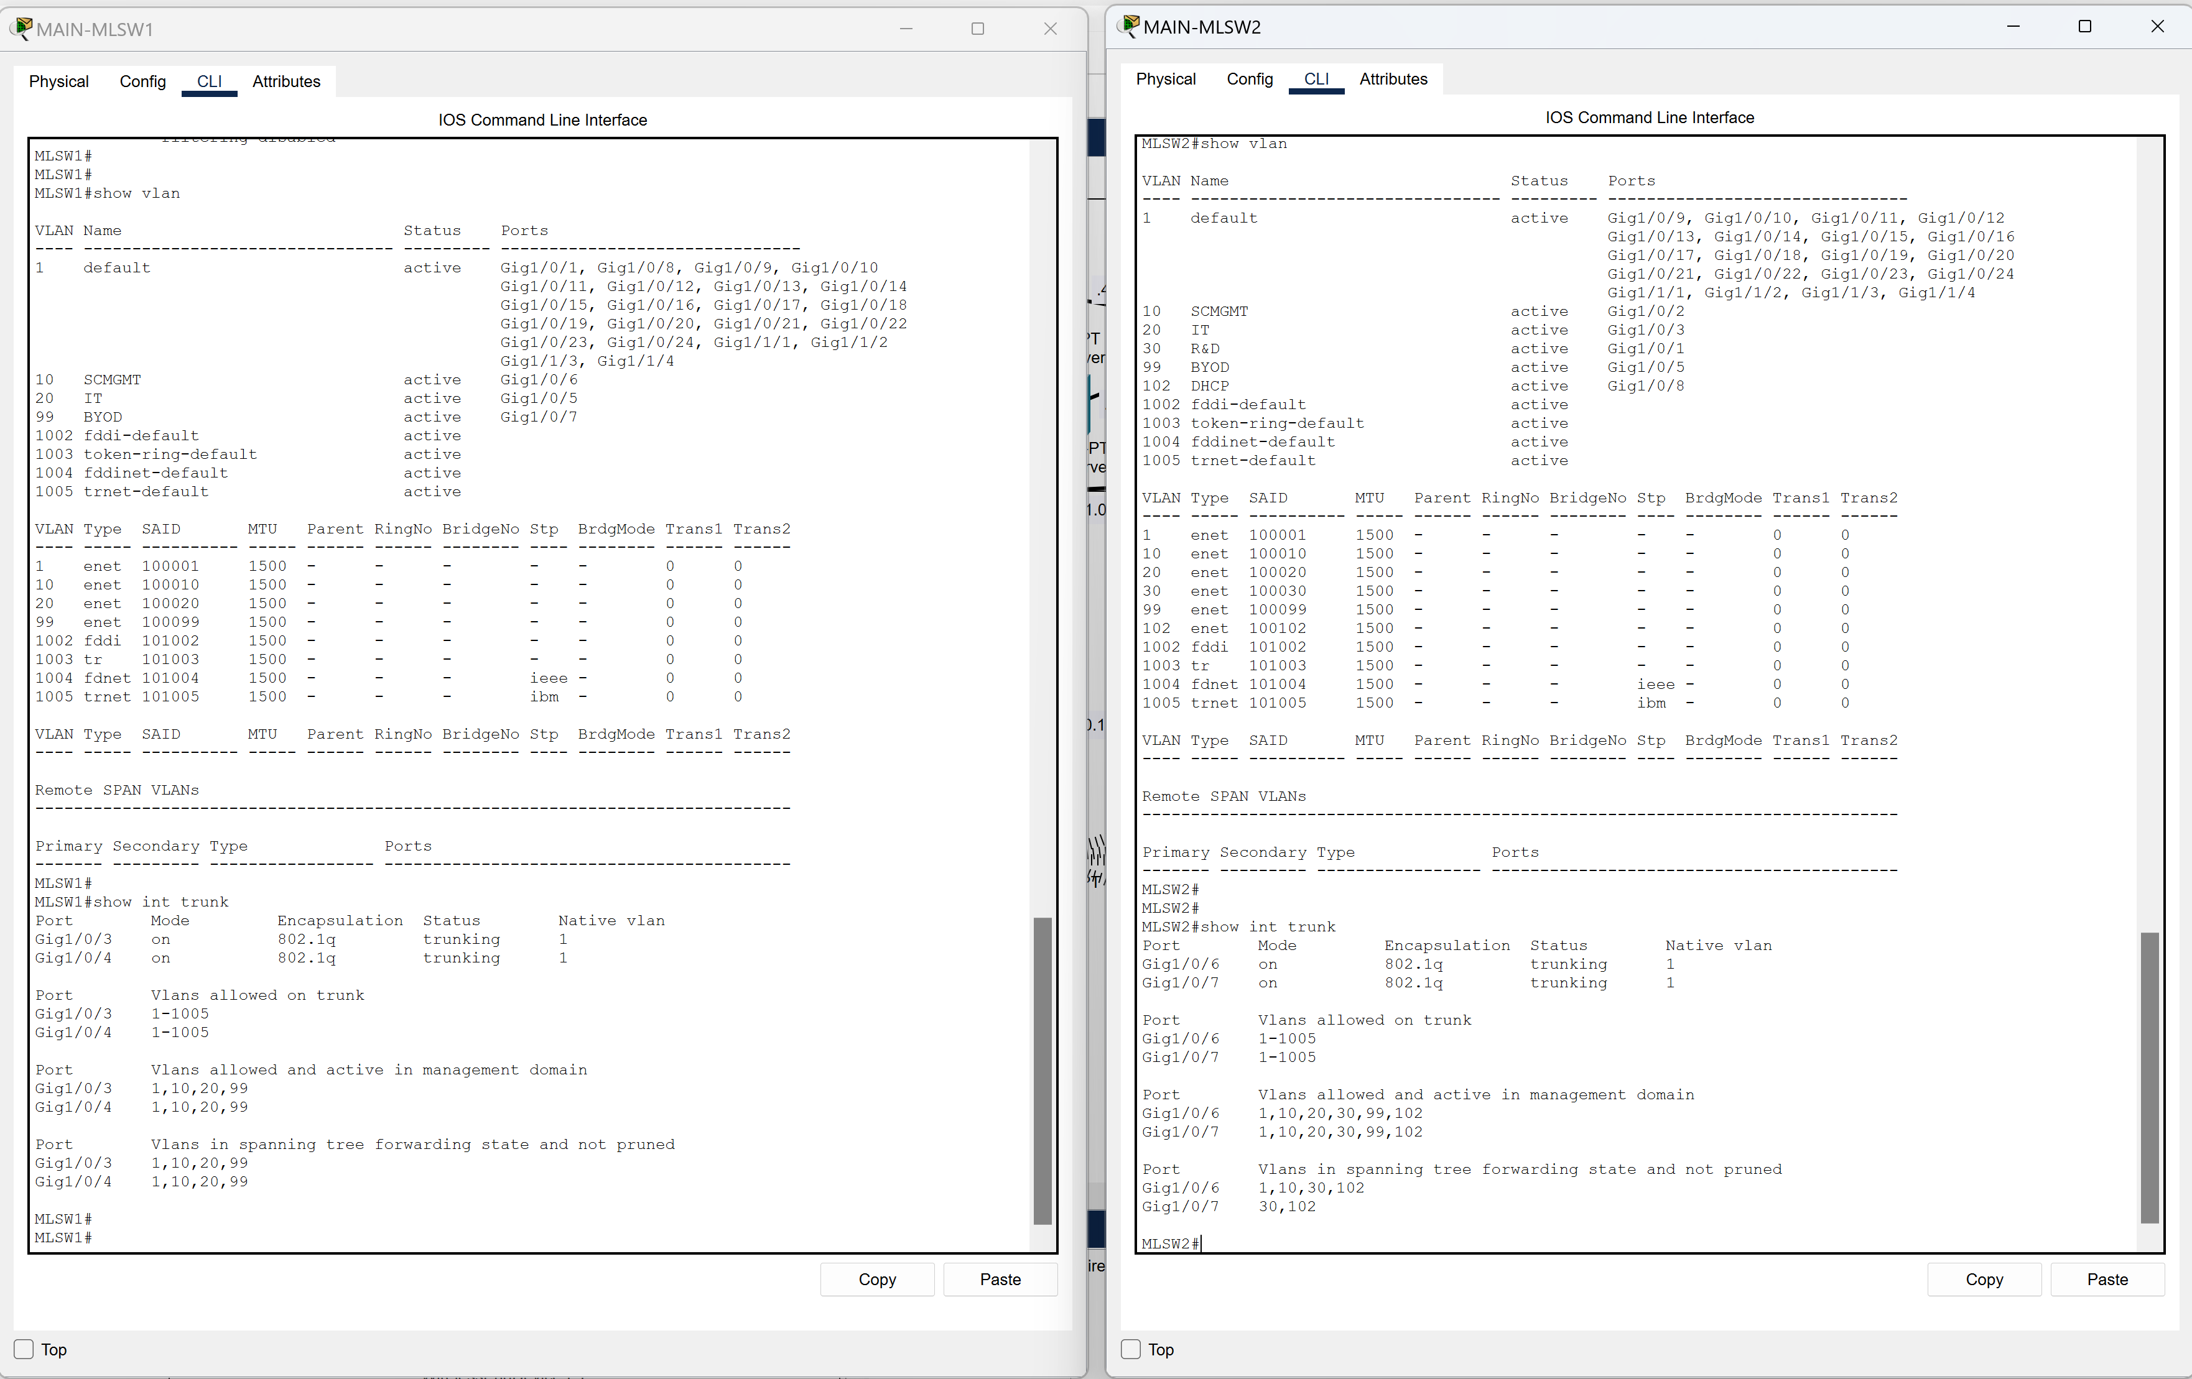

*VLAN configurations on the MGMT-SW, IT-SW, and Guest-SW:*

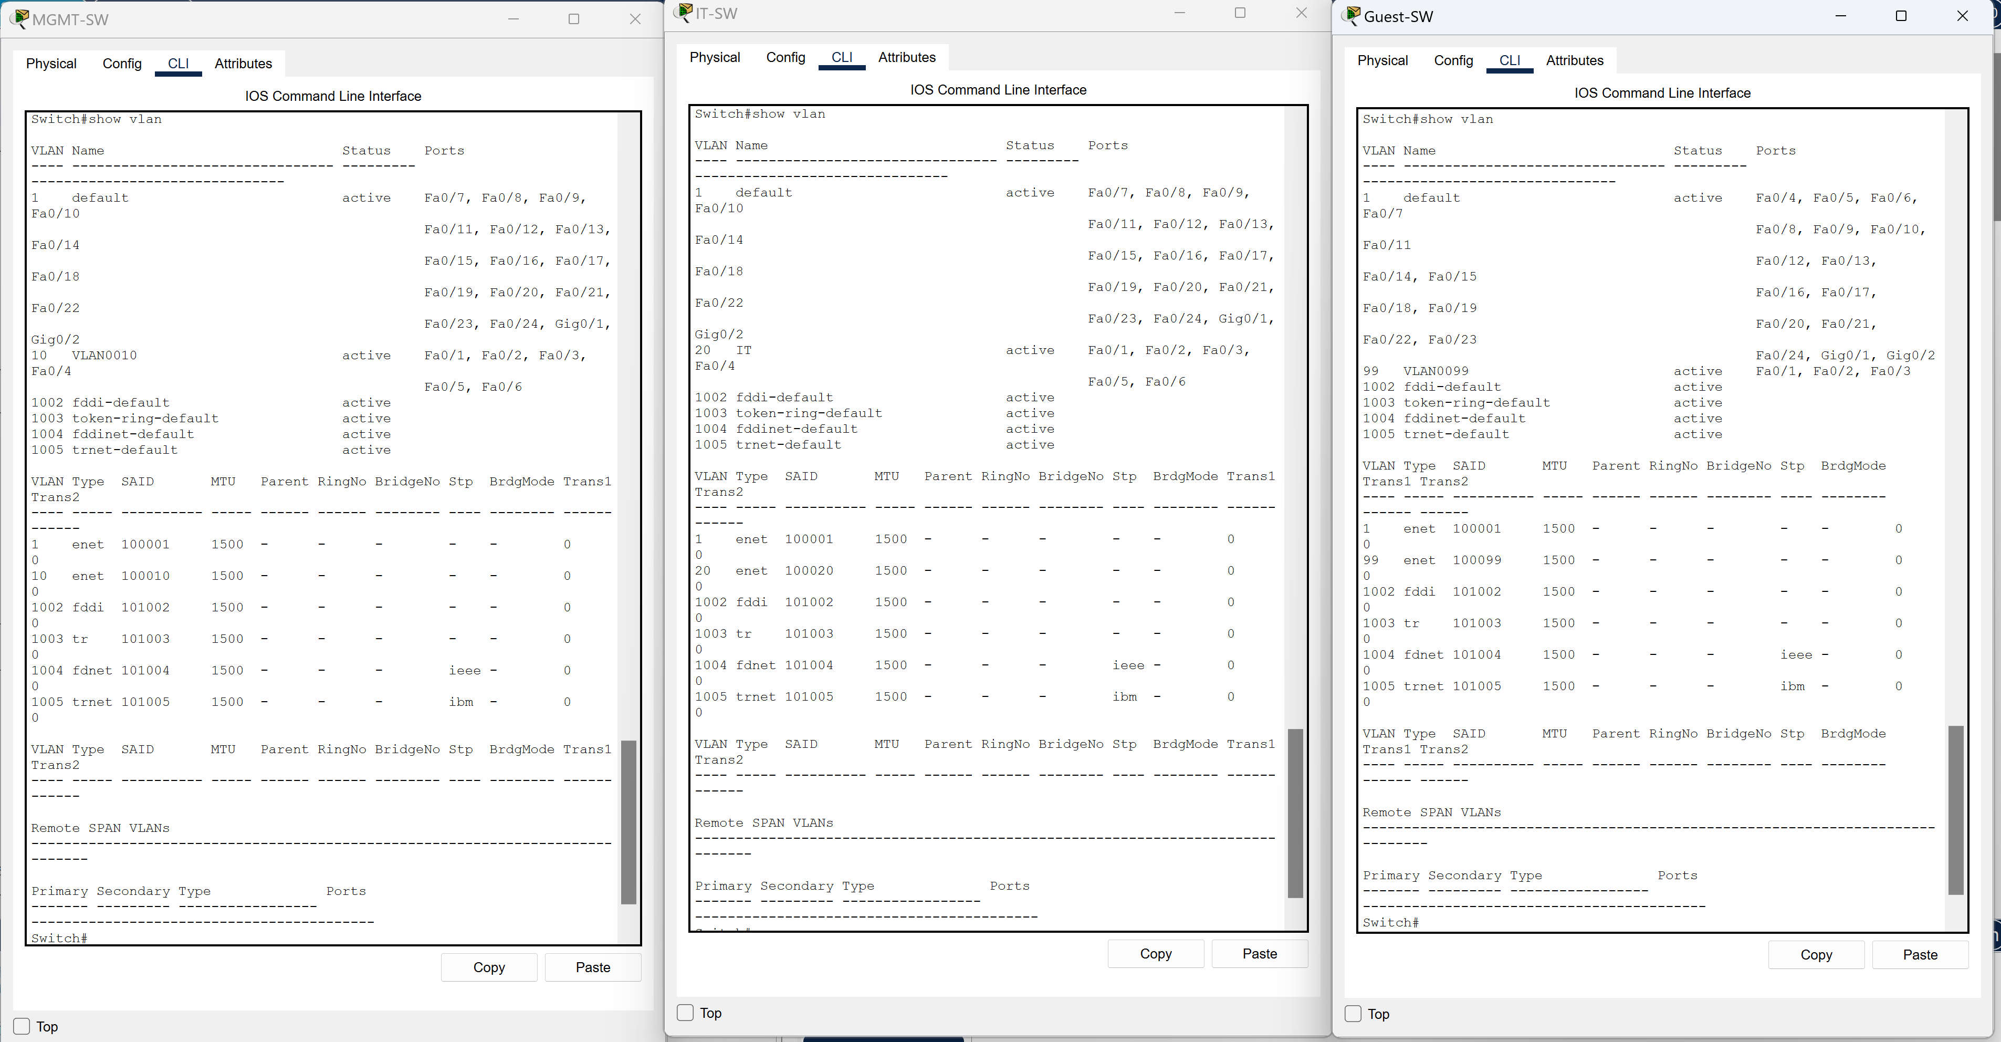

# Test Case #8: Basic or Advanced Networking

## Custom Test Case

*Define a* ***custom test case*** *to be run within your network project aligned to your specific organizational need or opportunity identified in Task 1. The custom test case should be equivalent in scope and requirements to the predefined test cases and pertain to basic or advanced networking.*

 My custom test case for advanced networking is to configure OSPF connectivity between all locations. I've established connectivity from the ENG department to all other departments but not from other departments to this department as per Test Case 1. I've established OSPF and firewall rules to accomplish this.

## Functionality

*Describe the* ***functionality*** *of the test case in relation to your network project. Identify the relevant tools (devices, subnets, etc.) used in this test case and their specific interactions.*

**Functionality**: I should be able to access all devices in the Monterey location from the 192.168.40.0/24 department using OSPF. I would first have to established OSPF Area 0 on the outside routers in order provide a backbone area that can share routes between both locations. I will use Area 1 for the Monterey location and Area 2 for the Santa Cruz location. My decision to set up 2 separate Areas for the different locations instead of expanding Area 0 to encompass the Monterey location and the outside routers is due to the smaller routing tables. Smaller routing tables will ensure efficient data routing, faster convergence, and leave room for expansion in the future.

## Network Diagram or Segment

*Provide a* ***network diagram or segment*** *visualizing the topology and devices used in this test case.*



## Testing Method

*Summarize the* ***testing method*** *used to verify functionality of the network project within the virtual lab environment, including any metrics of success.*

**Testing**: To test the connectivity of the devices and functionality of OSPF, I went into the routing tables on each device and saw that they have been populated with routes from OSPF as seen in the screenshots below. After verifying that the links formed OSPF adjacencies I would then go into a device in each department and attempt to ping a device outside the location to verify connectivity. For example, from RD-LPT2 (192.168.3.3) I was able to ping FACTORY-ISP (205.200.20.1) with success. I did this for a device in each Monterey department. The ENG department in Santa Cruz has connectivity to all devices in the Monterey location.

## Process List

*Provide a comprehensive* ***process list*** *of the steps taken within the network project to run the testing method. Include screenshots to illustrate the process and ensure clarity for others attempting to replicate the test.*

**Steps**: First, I would have to set up OSPF Area 0 on the routers. I started at the INTERNET router and entered the command "router ospf 1" which established the OSPF process ID. I then advertised the connected networks through OSPF by entering, "network 20.20.20.0 0.0.0.3 area " and "network 30.30.30.0 0.0.0.3 area 0". To form an adjacency, I would then have to go into the other two routers and do similar steps. On MAIN-ISP I entered "router ospf 1", "network 20.20.20.0 0.0.0.3 area 0", and "network 105.100.10.0 0.0.0.3 area 0". On the FACTORY-ISP I entered "router ospf 1", "network 30.30.30.0 0.0.0.3 area 0", and "network 205.200.20.0 0.0.0.3 area 0". After the backbone area was established on the routers, I would then have to add an additional backbone route on the outside facing networks of the FWs and a separate OSPF Area for all other networks. The DMZ, INSIDE, and INSIDE2 facing networks were established on area 1 and connected to the backbone through the OUTSIDE facing interface on MAIN-FW. Area 2 was configured on the INSIDE facing network on FACTORY-FW was also connected to the backbone through the OUTSIDE facing interface. The commands to configure the above are seen below. The routers and MLSWs use a wildcard mask, while the FWs use a normal mask.

MAIN-FW:

router ospf 50

network 10.20.1.20 255.255.255.252 area 1

network 10.20.1.0 255.255.255.252 area 1

network 10.20.2.0 255.255.255.240 area 1

network 105.100.10.0 255.255.255.252 area 0

MAIN-MLSW1:

router ospf 50

network 10.20.1.0 0.0.0.3 area 1

network 192.168.1.0 0.0.0.255 area 1

network 192.168.2.0 0.0.0.255 area 1

network 192.168.3.0 0.0.0.255 area 1

network 192.168.99.0 0.0.0.255 area 1

MAIN-MLSW2:

router ospf 50

network 10.20.1.20 0.0.0.3 area 1

network 192.168.1.0 0.0.0.3 area 1

network 192.168.2.0 0.0.0.255 area 1

network 192.168.1.0 0.0.0.255 area 1

network 192.168.3.0 0.0.0.255 area 1

network 192.168.99.0 0.0.0.255 area 1

FACTORY-FW:

router ospf 20

router-id 1.1.1.20

network 192.168.40.0 255.255.255.0 area 2

network 205.200.20.0 255.255.255.252 area 0

Screenshots for Test Case 8

*Shows the OSPF configuration, the entire routing table, and the OSPF routes on the routers:*

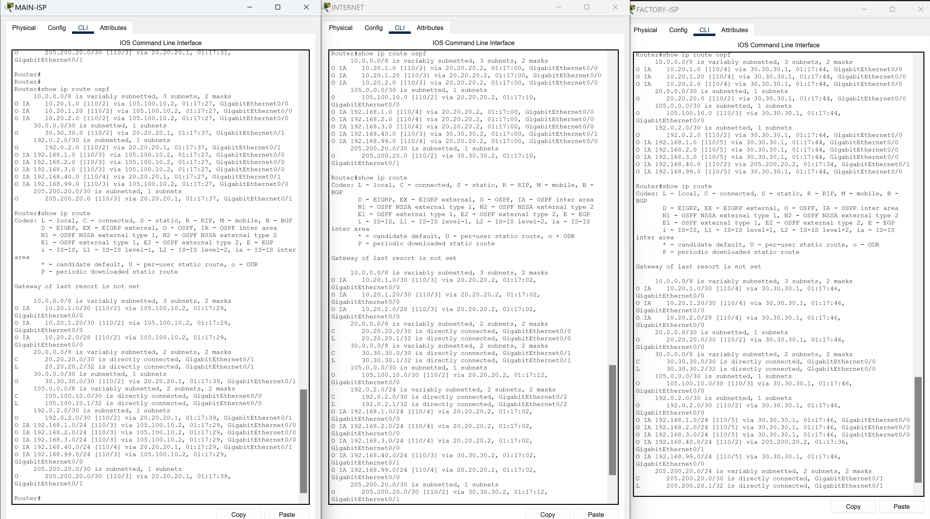

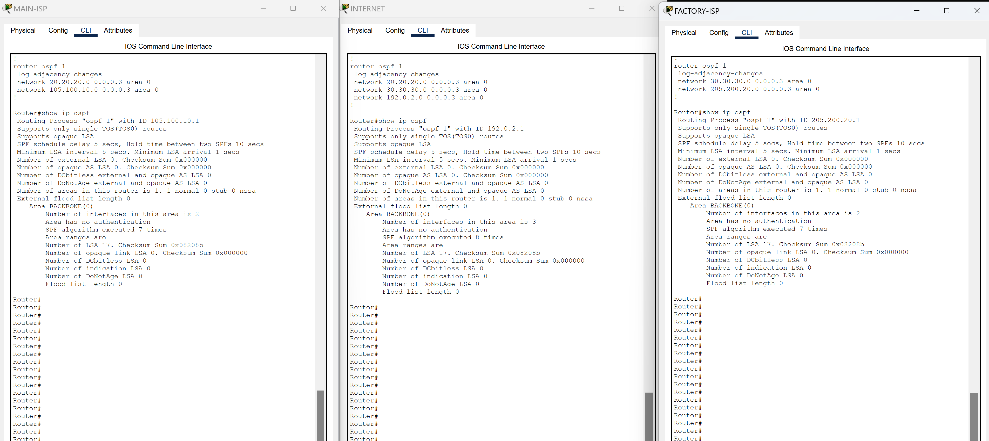

*Shows the OSPF configuration, the entire routing table, and the OSPF routes on MLSW1 and MLSW2:* 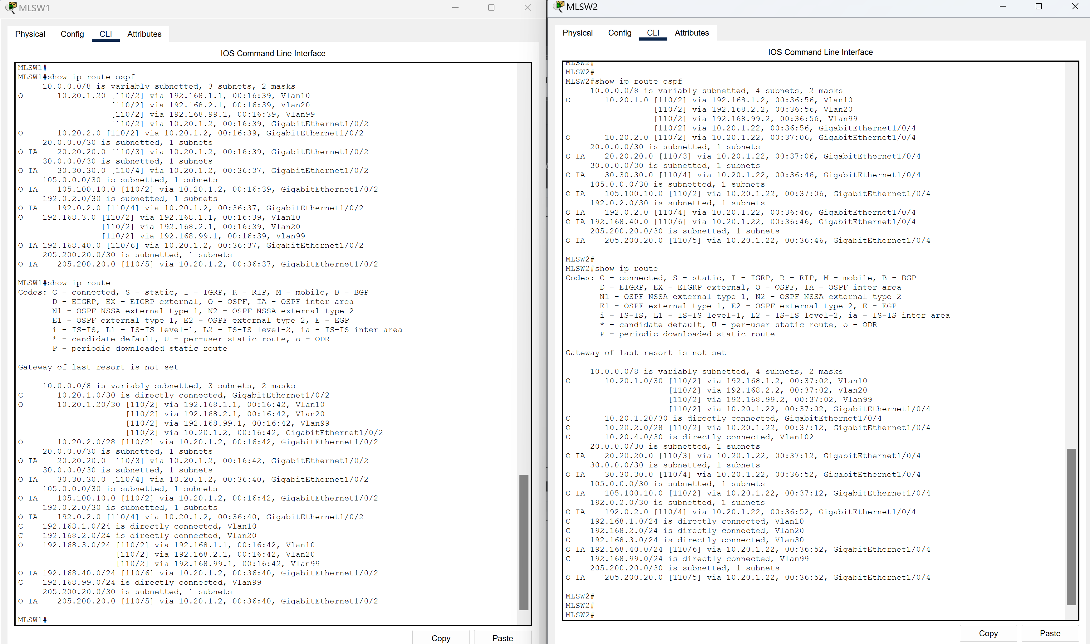

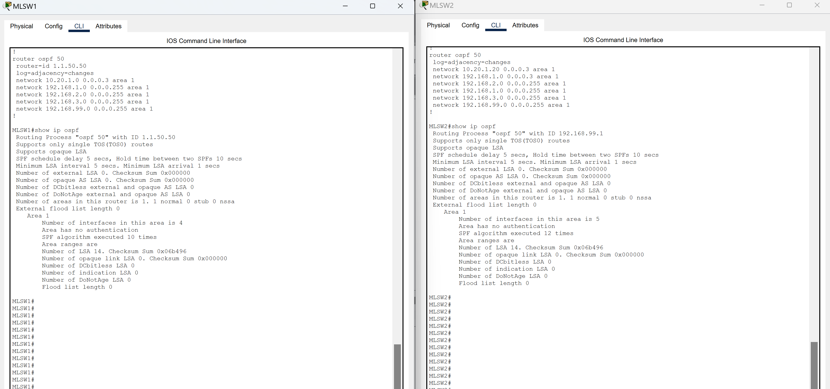

*Shows the routing table, and the OSPF configuration and routes on MAIN-FW and FACTORY-FW:*

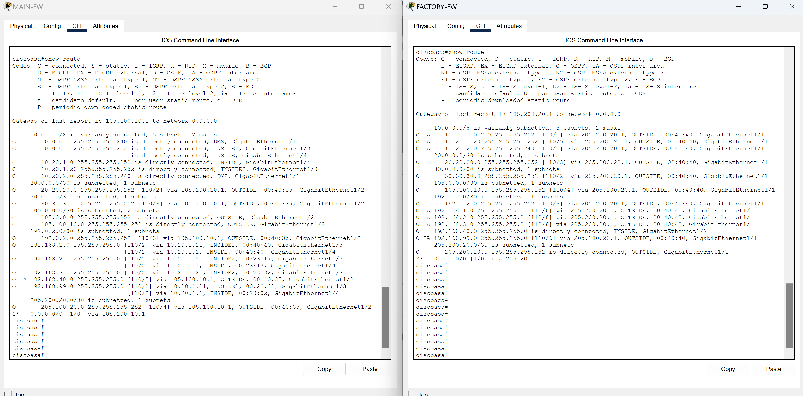

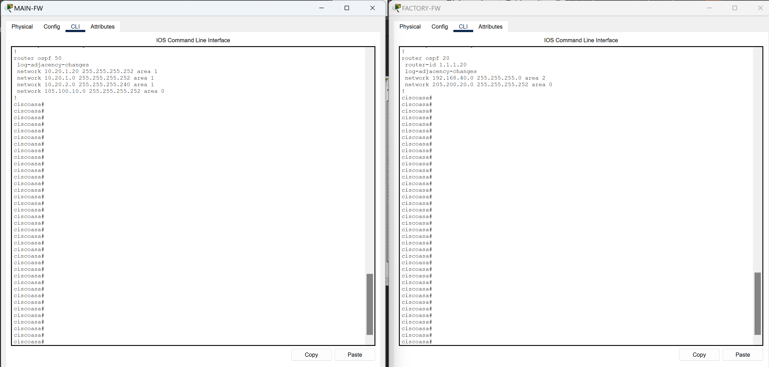

# Test Case #9: IPSec

## Custom Test Case

*Define a* ***custom test case*** *to be run within your network project aligned to your specific organizational need or opportunity identified in Task 1. The custom test case should be equivalent in scope and requirements to the predefined test cases and pertain to IPSec.*

I've setup an IPsec Point-to-Point connection between the two firewalls to establish secure communication by using tunneling. The FWs have ACLs configured to allow specific types of connections including SSH.

## Functionality

*Describe the* ***functionality*** *of the test case in relation to your network project. Identify the relevant tools (devices, subnets, etc.) used in this test case and their specific interactions.*

**Functionality**: I should have a Point-to-Point IPsec tunnel configured between the MAIN-FW and the FACTORY-FW. The tunnel should be configured on their OUTSIDE interfaces for establishing functional Point-to-Point IPsec.

## Network Diagram or Segment

*Provide a* ***network diagram or segment*** *visualizing the topology and devices used in this test case.*

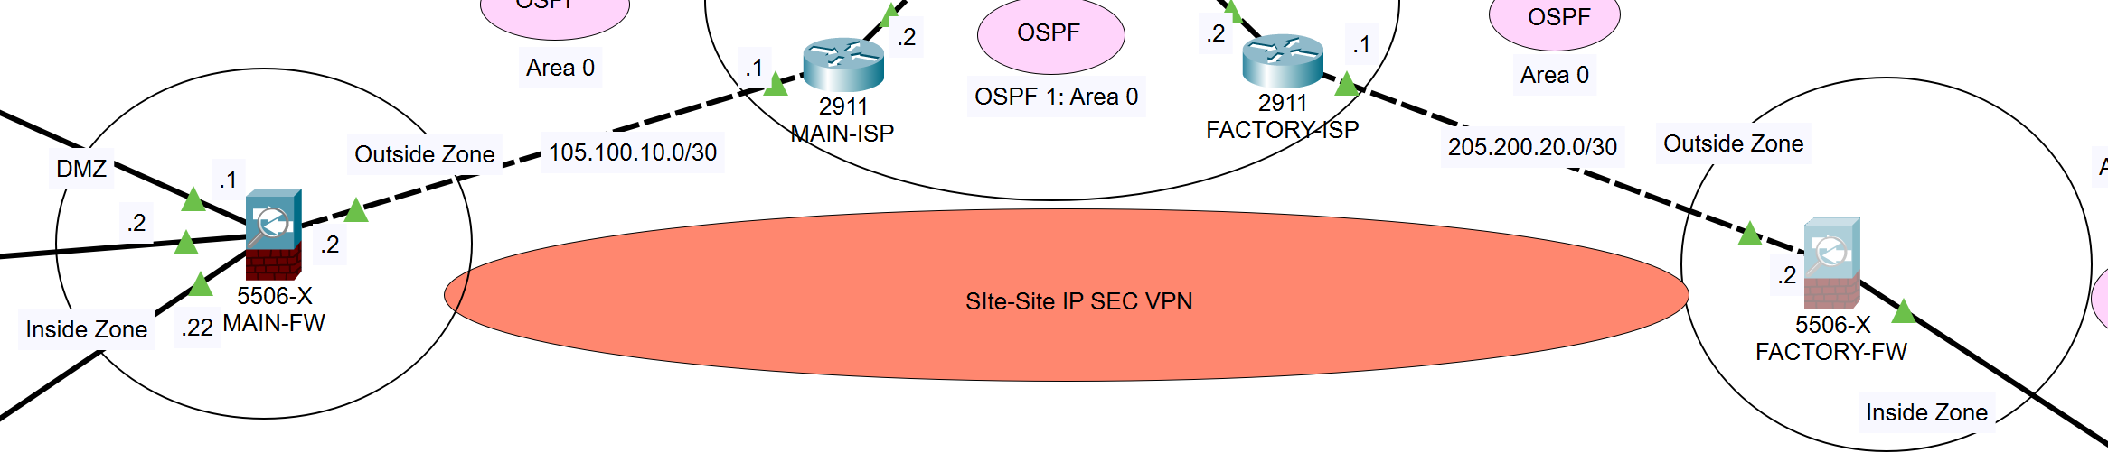

## Testing Method

*Summarize the* ***testing method*** *used to verify functionality of the network project within the virtual lab environment, including any metrics of success.*

**Testing**: To test successful configuration of my IPsec tunnel I used the “show run” and “show crypto isakmp sa” on both FWs. Through verification of matching configurations, I successfully confirmed that Point-to-Point IPSec was setup successfully. To further validate the IPSec tunnel, I ensured connectivity by running internal ping commands that were able to successfully reach devices on the opposite side of the VPN tunnel.

## Process List

*Provide a comprehensive* ***process list*** *of the steps taken within the network project to run the testing method. Include screenshots to illustrate the process and ensure clarity for others attempting to replicate the test.*

**Steps**: The process of setting up the IPsec tunnel between MAIN-FW and FACTORY-FW consisted of several different CLI commands that are show below:

MAIN-FW:

crypto ikev1 policy 10

hash sha

authentication pre-share

group 2

lifetime 86400

encryption 3des

tunnel-group 205.200.20.2 type IP-sec-l2l

tunnel-group 205.200.20.2 IPSEC-Attributes

ikev1 pre-shared-key cisco

crypto IPsec ikev1 transform-set TSET esp-3des esp-sha-hmac

access-list VPN permit udp any any eq 123

access-list VPN permit ip 192.168.40.0 255.255.255.0 any

crypto map CMAP 10 set peer 205.200.20.2

crypto map CMAP 10 set ikev1 transform-set TSET

crypto map CMAP 10 match address VPN

crypto map CMAP interface OUTSIDE

crypto ikev1 enable OUTSIDE

crypto map CMAP interface OUTSIDE

FACTORY-FW:

crypto ikev1 policy 10

hash sha

authentication pre-share

group 2

lifetime 86400

encryption 3des

tunnel-group 105.100.10.2 type IP-sec-l2l

tunnel-group 105.100.10.2 IPSEC-Atrributes

ikev1 pre-shared-key cisco

crypto IPsec ikev1 transform-set TSET esp-3des esp-sha-hmac

access-list VPN permit udp any any eq 123

crypto map CMAP 10 set peer 105.100.10.2

crypto map CMAP 10 set ikev1 transform-set TSET

crypto map CMAP 10 match address VPN

crypto map CMAP interface OUTSIDE

crypto ikev1 enable OUTSIDE

crypto map CMAP interface OUTSIDE

Screenshots for Test Case 9:

*Configurations of the ‘VPN’ ACL and IPsec tunnel on MAIN-FW and FACTORY-FW:*

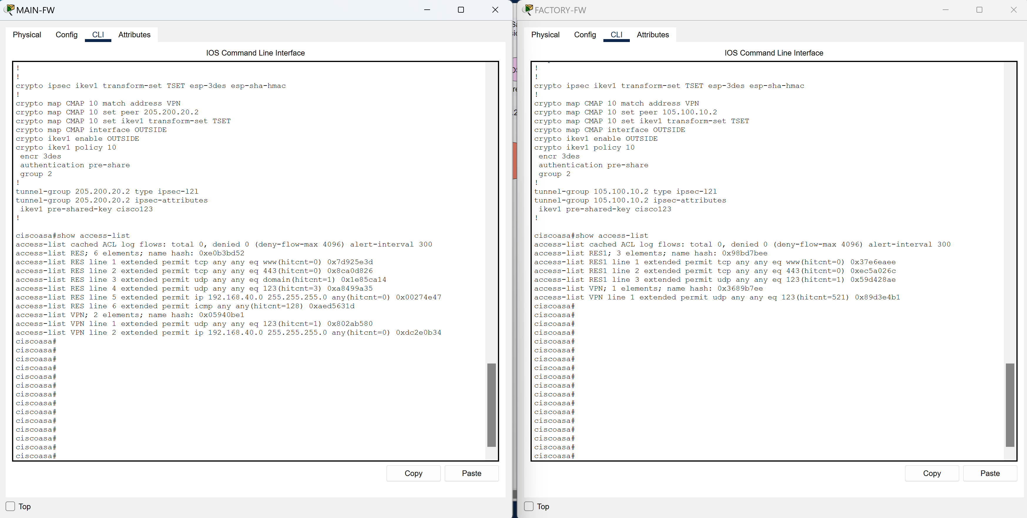

# Test Case #10: Network Security

## Custom Test Case

*Define a* ***custom test case*** *to be run within your network project aligned to your specific organizational need or opportunity identified in Task 1. The custom test case should be equivalent in scope and requirements to the predefined test cases and pertain to network security.*

In the scenario of Building C, I've setup an admin PC that requires SSH connectivity to the MAIN-FW in the Monterey location. This connection will be confirmed with an AAA server that will verify the credentials from the ADMIN-PC in the ENG department. The AAA credentials will be different from the local device credentials to demonstrate that the AAA is functioning properly. I've also configured NAT on the two FWs for network address translation outside the network for best practice.

## Functionality

*Describe the* ***functionality*** *of the test case in relation to your network project. Identify the relevant tools (devices, subnets, etc.) used in this test case and their specific interactions.*

**Functionality**: I should be able to SSH into g1/2 on MAIN-FW which is the outside facing interface with the IP address of 105.100.10.2 from the ADMIN-PC. I should also be able to SSH into g1/2 on FACTORY-FW which is the inside facing interface with the IP of 192.168.40.1 from the ADMIN-PC. The ADMIN-PC has the IP address of 192.168.40.4 and is in the 192.168.40.0/24 ENG department. SSH should be authenticated by the AAA server. I should also have successful Network Address Translation from the internal devices.

## Network Diagram or Segment

*Provide a* ***network diagram or segment*** *visualizing the topology and devices used in this test case.*

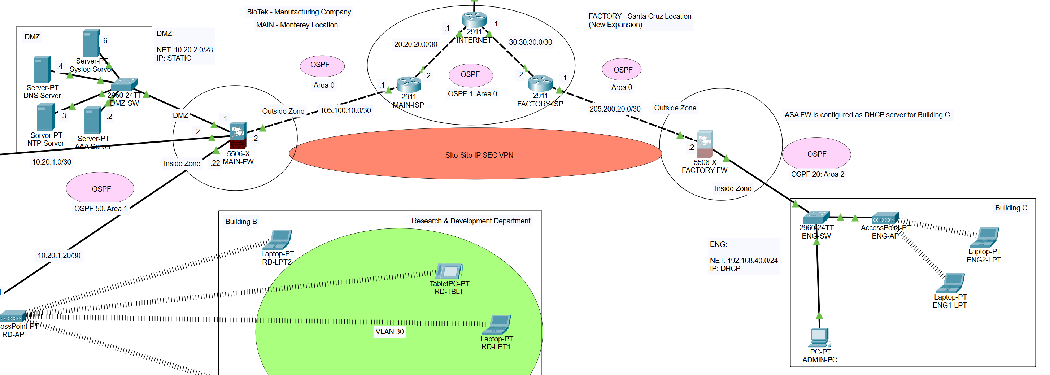

## Testing Method

*Summarize the* ***testing method*** *used to verify functionality of the network project within the virtual lab environment, including any metrics of success.*

**Testing**: To test working functionality, I logged into the terminal of the ADMIN-PC and used the command "ssh -l mac 105.100.10.2" which indicates the username "mac" that was set up in the AAA server inside the DMZ in the Monterey location. After initializing a connection, I am then prompted for the AAA password that was setup in the AAA with the username. I used the password "cisco" which allows connection into the MAIN-FW. Next, I'm prompted for the devices local password which is "cisco123". To test if NAT is working properly, I used the ping command on a device from within the Monterey location as well as within the ENG department in the Santa Cruz location to an outside router. Afterwards I went on each FW and used the command, “show nat” to verify that ip addresses were being translated successfully.

## Process List

*Provide a comprehensive* ***process list*** *of the steps taken within the network project to run the testing method. Include screenshots to illustrate the process and ensure clarity for others attempting to replicate the test.*

**Steps**: The first step in the process is setting up the AAA server by going into services and selecting the AAA option. Within the AAA tab I would first have to turn the service on and then input the correct data for the correct fields. Client Name: MAIN-FW, Client IP: 10.20.2.1, Secret: cisco123, Username: mac, Password: cisco. Additionally, I’ve configured NAT on the FWs for best practice, as seen below. After setting up the AAA server I had to configure the FWs to allow SSH traffic from the ADMIN-PC in the ENG department (192.168.40.0/24). The commands that I’ve mentioned above are seen below:

MAIN-FW:

ssh 205.200.20.2 255.255.255.255 OUTSIDE

ssh timeout 5

object network BYOD

subnet 192.168.99.0 255.255.255.0

object network IT

subnet 192.168.2.0 255.255.255.0

object network MGMT

subnet 192.168.1.0 255.255.255.0

object network RD

subnet 192.168.3.0 255.255.255.0

nat (INSIDE,OUTSIDE) dynamic interface

FACTORY-FW:

ssh 192.168.40.4 255.255.255.255 INSIDE

ssh timeout 5

object network ENG

subnet 192.168.40.0 255.255.255.0

nat (INSIDE,OUTSIDE) dynamic interface

Screenshots for Test Case 10

*Configuration of SSH and AAA on the MAIN-FW and FACTORY-FW:*

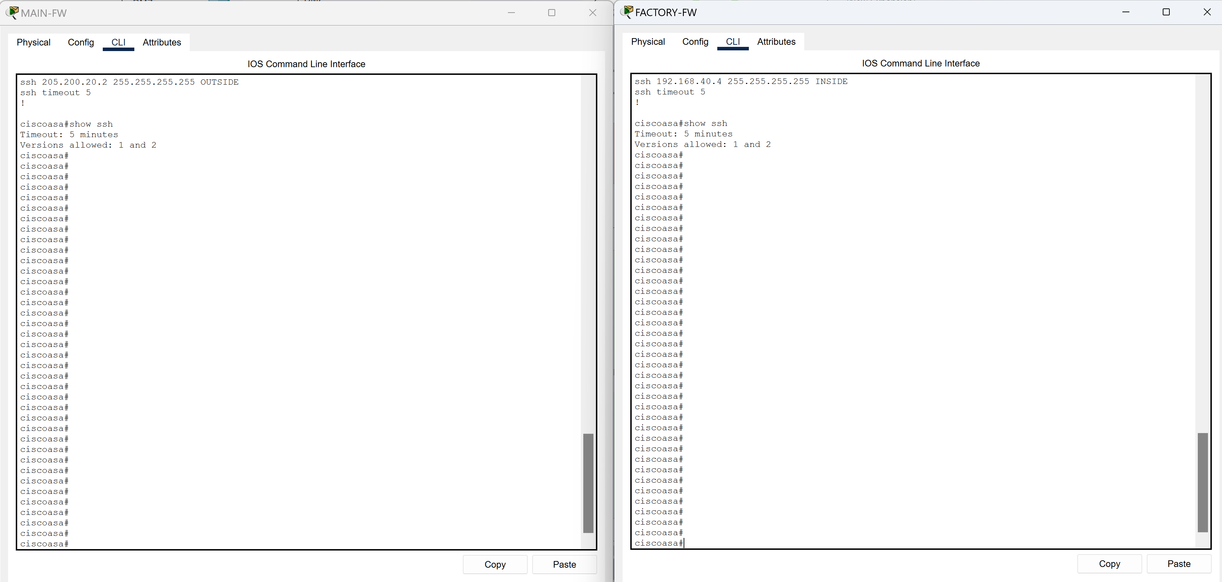

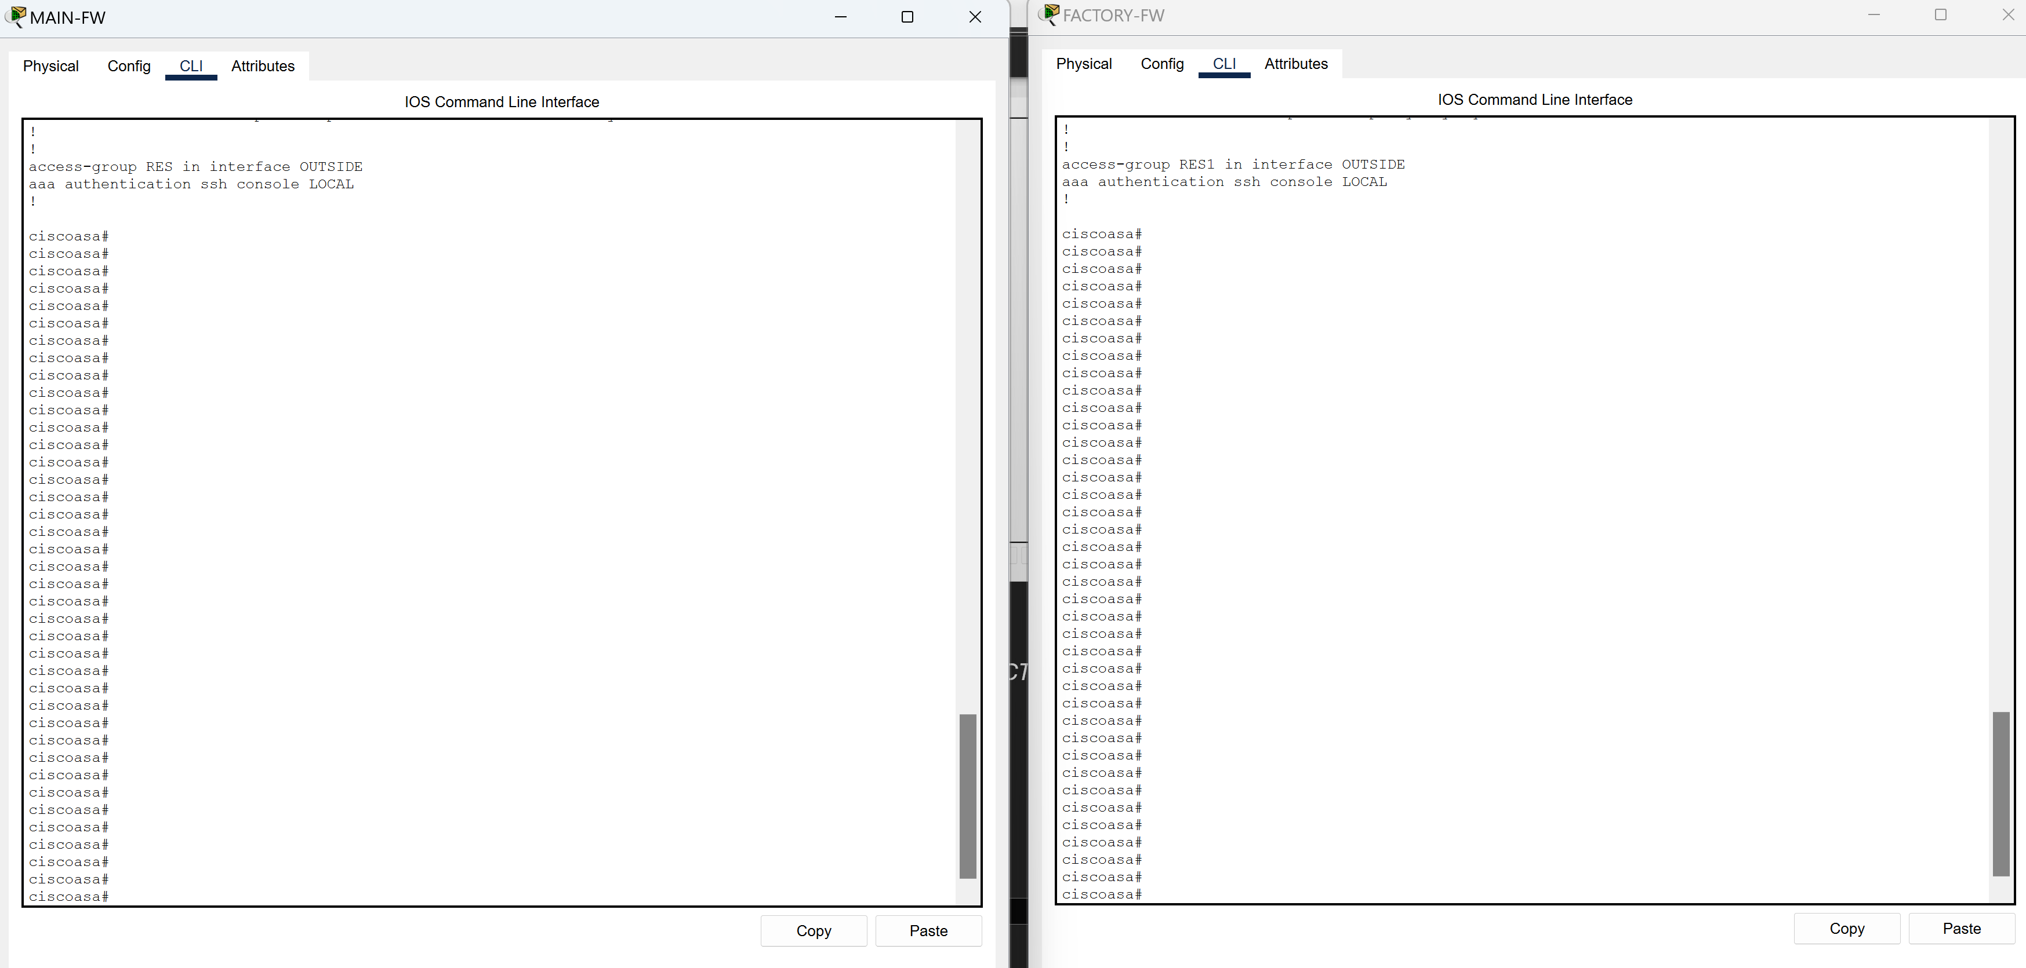

*Configuration of NAT on the MAIN-FW and FACTORY-FW:*

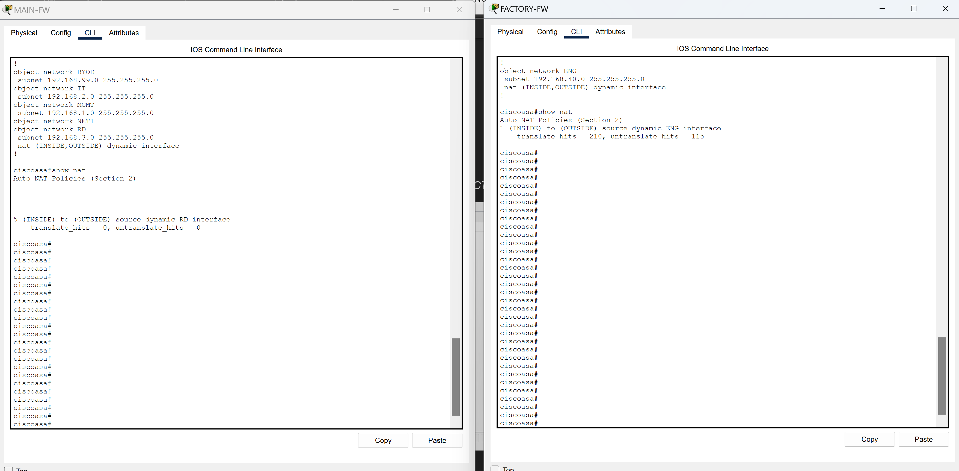

*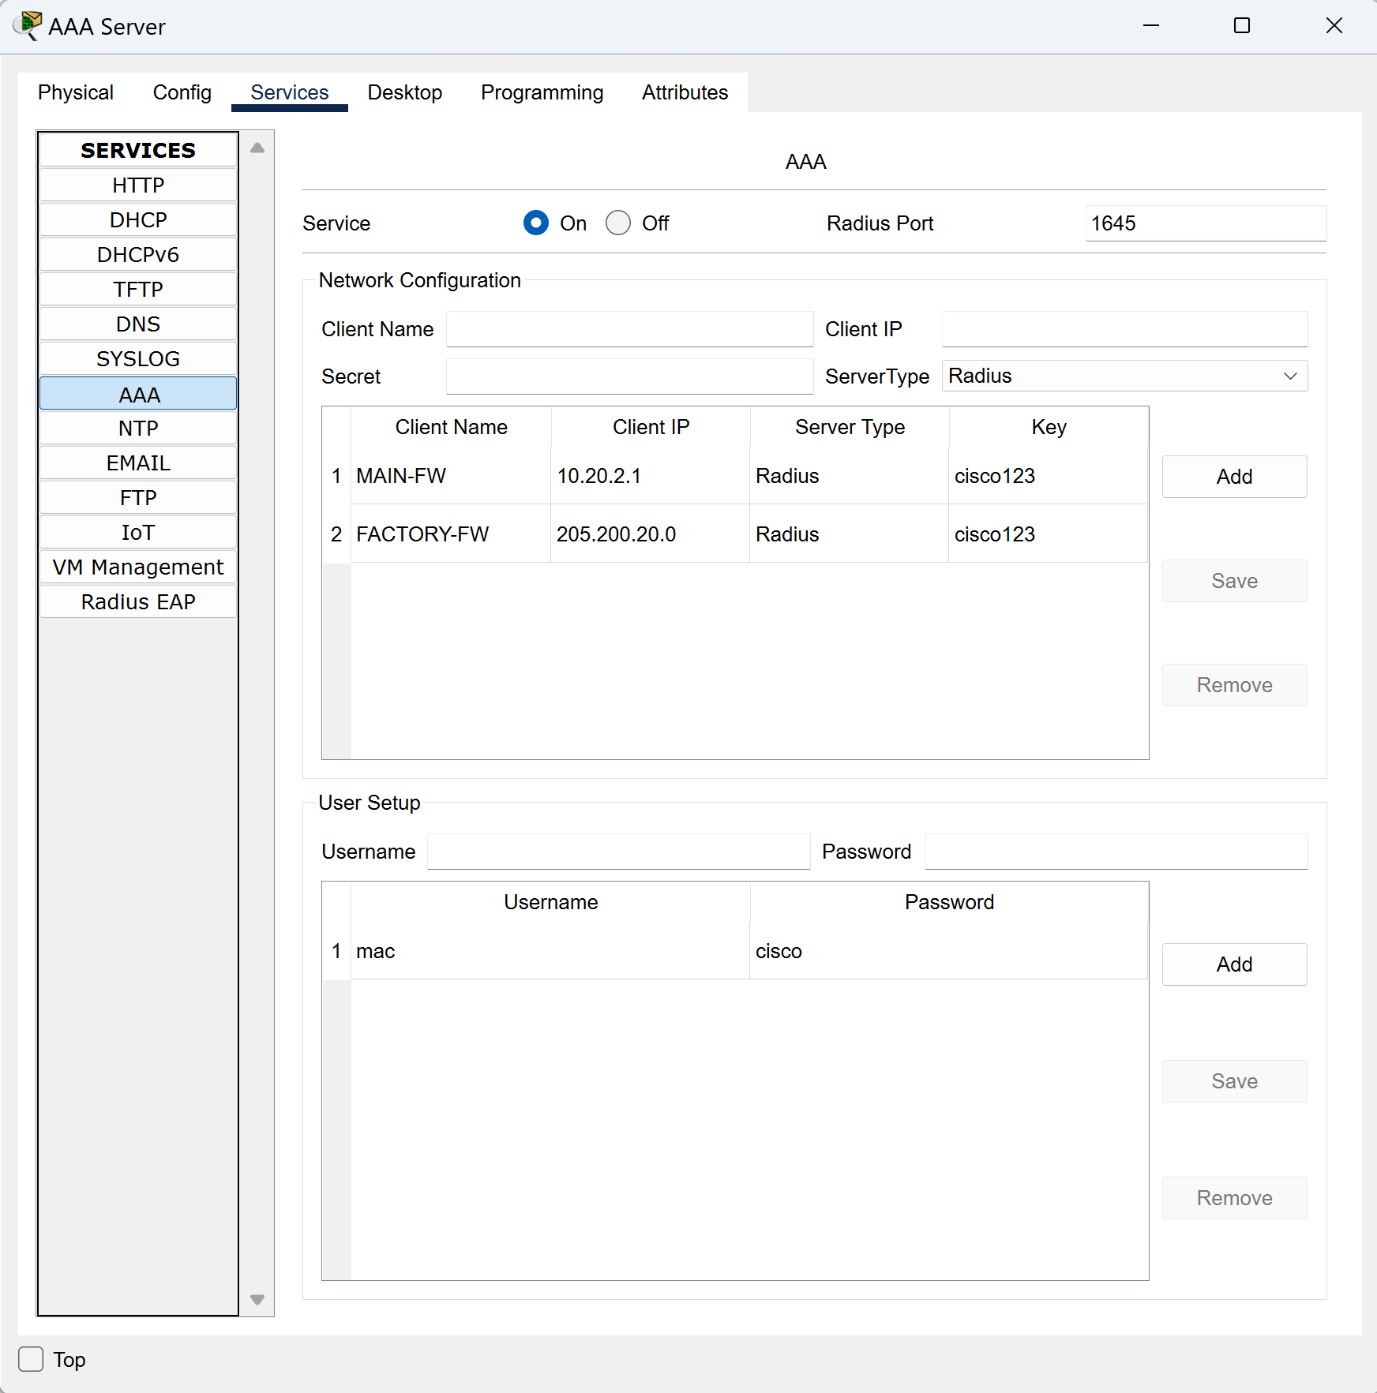Configuration of the AAA Server:*

# Network Troubleshooting

*Discuss how you analyzed the network to identify, troubleshoot, and resolve issues during development or when ensuring functionality of the test cases.*

Analyzing my network to identify, troubleshoot, and resolve issues required a meticulous approach. I first created a detailed map of the network. I used my network diagram to visualize the layout, including all devices, connections, and configurations. Using ‘ping’ and ‘tracert’ commands alongside the simulation tools in Packet Tracer, I tested connectivity and pinpointed where packets were dropping. My troubleshooting steps involved reviewing and revising configurations as needed and verifying that all device settings were correct and consistent. It was also important to ensure that Access Control Lists and Firewalls weren’t unintentionally blocking traffic. Simulation mode in Packet Tracer was extremely helpful in testing network changes, as it allowed me to visualize packet flow and anticipate impacts. Finally, I prioritized efficiency and continuous progress by keeping a detailed record of changes made and issues encountered throughout the process, ensuring I knew exactly where to resume.